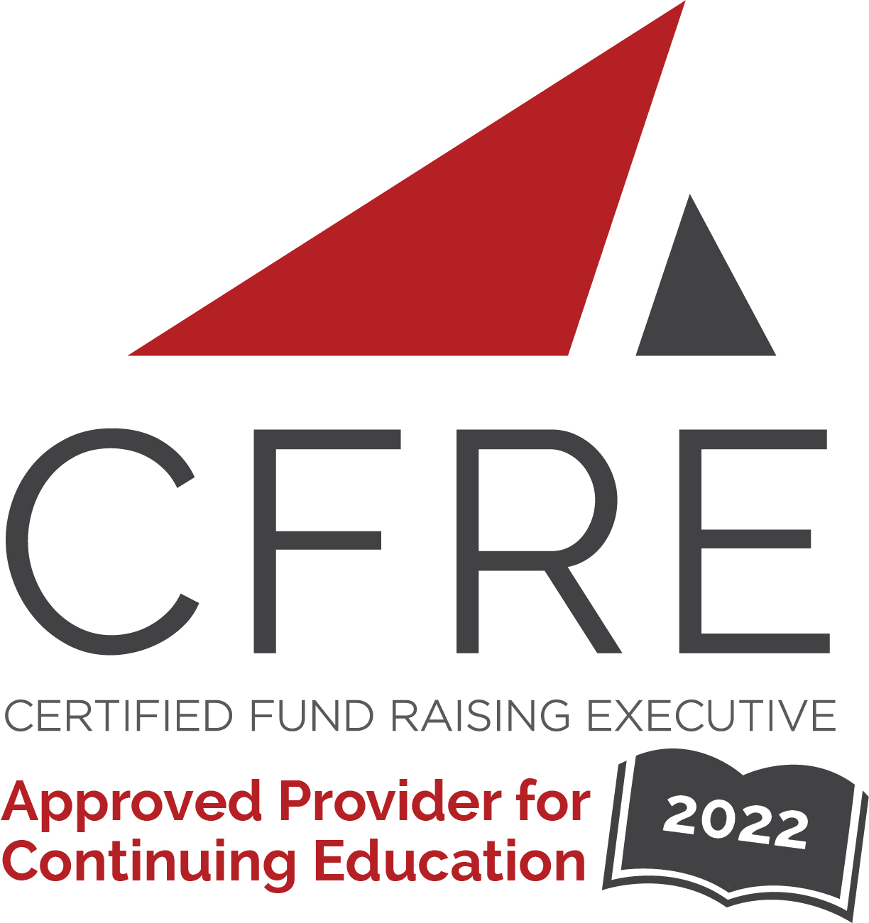  CFRE International has developed this form as a way for you to quickly track (and keep in your files!) the continuing education sessions you have attended. Simply check the boxes next to the sessions you attended. At the end of the conference, add up the total number of hours. Keep this sheet and you will be ready to complete your application form. All of the session slots listed are eligible for continuing education points on your CFRE application for initial certification and/or recertification. Sessions not listed here are not eligible for points. |  | CONTINUING EDUCATION POINTS TRACKER

Activity Organizer: - AFP International
Title of Activity: - AFP ICON 2022
Names of Presenter(s): - Various
Dates and Location: - April 30 – May 4, 2022, Las Vegas, NV

Date: Saturday, April 30 – Sunday May 1, 2022
Pre-Conference Workshop: 8:00 [am] – 5:00 [pm] (16 pts)
- [CFRE Refresher]
- [Elevate Your Gifts In Wills Programs Through Impactful Donor Journeys]
- [Fundamentals Of Fundraising]

Date: Sunday, May 1, 2022
Pre-Conference Workshop: 8:00 [am] – 5:00 [pm] (8 pts)
- [Capital Campaign Fundraising: Ready, Set, Go!]
- [Donor Retention: A Self-Assessment Workshop]
- [The Donor Decision Lab: Using The Behavioral Science Underpinning Philanthropy]
- [Yes, I Want More Major Gifts! Inspire, Ask And Repeat Transformational Giving!]

Date: Monday, May 2, 2022
Session 1: 9:00 [am] – 10:15 [am] (1.25 pts)
- [Putting our fundraising cards on the table: A conversation with funders and practitioners on equity-centered philanthropy]
- [Addressing Mental Health and Ending Stigma in the Workplace: Moving from Awareness to Action]
- [Bridge the gap: finding balance between virtual and in-person events]
- [Re-ignite your fundraisers by cultivating a culture of collaboration, creativity, and trust]
- [Boost Latinx-Focused Philanthropy And Charitable Efforts]
- [2020 Vs. 2021 Fundraising Stats: Using AFPS Donor Giving Data To Improve Your Fundraising Results]
- [Grant Professionals Have Ethical Dilemmas Too! How The GPA Code Of Ethics Helps]
- [Fairy Tale Wedding Or Marriage Of Convenience...Creating The Perfect Union Between Business And Your Nonprofit]
- [Reinventing Capital Campaigns: How We Shortened Cultivation Time And Opened Ask Conversations On Zoom]
- [What Happens In Vegas, Stays In Vegas: Fundraising Fails & How To Survive Them]
- [What Every Board Member Wants Every Fundraiser To Know]
- [How To Craft An Impact Report That Inspires, Engages And Activates Donors]
- [You Need A Killer Opening Act: The Role Of Annual Fund In Major Giving]

Date: Monday, May 2, 2022
Session 2: 10:45 [am] – 12:00 [pm] (1.25 pts)
- [The Generosity Crisis: How A.I. Can Reignite Radical Connection]
- [How To Lead Volunteer Committees To Success]
- [A Seat At The Table Or Part Of The Meal: Creating A Culture Of Inclusion]
- [You’re Richer Than Your Think: Finding Hidden Gems In Your Donor Data]
- [Advocacy And Philanthropy: Turning Donors Into Powerful Advocates]
- [The Future Of Fundraising]
- [Don’t Lose $: Get The Corporate And Individual Gift In Just One Ask!]
- [Winning Fundraising Campaigns That Hit The Fundraising Jackpot]
- [From Young Pro To Emerging Leader: How To Maximize AFP To Build Your Career!]
- [Panel: Challenges In Fundraising. Being Black & A Man In Fundraising]
- [Managing Up and Across at Your Healthcare Organization]
- [Bridging the Gap with Millennial Donors: How UNICEF USA Grew Its Donor Base by 300%]
- [You’ve Got the Chops: Speaking for Results (Part 1 - The Foundation)]
- [Donors and Digital Adaption: What you need to know to maximize your fundraising!]

Date: Monday, May 2, 2022
Session 3: 4:00 [pm] – 5:15 [pm] (1.25 pts)
- [When Small Becomes Big- Survival In A Large Healthcare Enterprise After A Merger]
- [Growing Your Monthly Giving Program From Good To Great To Mighty!]
- [Community-Centric Fundraising: Constituent Engagement Through A Lens Of Inclusion, Diversity, Equity And Access]
- [Continuing The Conversation On Being An Equitable, Inclusive, Diverse Leader]
- [Digital Integration: The New Game Changer (PANEL DISCUSSION)]
- [Bring The Heat: Learning To Lead Through Challenge]
- [Nonprofits And Influencer Marketing: A Case Study With Best Friends Animal Society]
- [The Reshape Of Human Engagement And Culture Of Philanthropy]
- [Making The Ask- 20 Decision Science Tools To Shape Your Solicitation]
- [Start Your Plan Here: Implementing A Big-League Relationship Management Program For Your Small Shop]
- [Stop, Collaborate, and Listen: How Three Las Vegas Nonprofits Answered The Call When The Need Was Greatest]

Date: Tuesday, May 3, 2022
Session 1: 8:00 [am] – 9:15 [am] (1.25 pts)
- [The Five Fund Development Planning Tools That Lead to Fundraising Success!]
- [Get serious about data-driven fundraising: How to unite data, technology and process to drive success.]
- [Your Development Team-- Essential Elements Beyond Fundraising Goals]
- [From New Delhi to New York, from Mumbai to Montreal: Indian Immigrants and Philanthropy]
- [Why Should I Give to You? 4 Keys to Answering Your Donors Most Fundamental Question]
- [Recruiting Diverse Board Members- Understanding The Value of Diverse Leaders Who Love Your Mission]
- [Visual Storytelling: Show, Don’t Tell]
- [The Capital Campaign Case Statement: Friend Or Foe To Equitable Fundraising?]
- [Fundraising From Couples: New Research On How Households Make Giving Decisions]
- [A New (and Better) Way To Win Grants]
- [Going Beyond Change: Transforming Nonprofit Culture from Charity Mindset to Social Justice]
- [Planned Giving in Your Hospital]
- [Let’s Get Creative: A Fresh Take On Year-Round Fundraising With Industry Trends And Real-Life Examples]
- [You’ve Got the Chops Part 2]
- [The Future of Fundraising is Consumer-Driven]

Date: Tuesday, May 3, 2022
Session 2: 10:15 [am] – 11:30 [am] (1.25 pts)
- [Fundraising in the Disability Space Without Using "Inspiration Porn" or Other Exploitation]
- [Acknowledgment Best Practices for Any Size Shop]
- [The Who, What, When, Where & Why of Launching a Fundraising Campaign]
- [Equity-Centered Philanthropy: Reaching donors of color through data]
- [The New Rules of Digital Fundraising: How to Convert (and Keep!) More Digital Donors]
- [Having It All and Doing It All - Balancing Being a Parent and a Professional]
- [Building Sustainable Corporate Partnerships  Decoding the Real Value of Sponsorships]
- [After The Pandemic: Perspectives On The Future Of High Value Fundraising]
- [10 Things Academics Know That Practitioners May Not]
- [Right Person, Right Time, Right Message: Leveraging LinkedIn to Prepare for the Big Ask]
- [Building Robust Partnerships with Medical Professionals]
- [Handling Objections: Donor Objections are a sign of Interest]
- [Donors ARE Data: Creating a Donor-Centered Fundraising Operation ]
- [Crypto Fundraising 101]

Date: Tuesday, May 3, 2022
Session 3: 1:15 [pm] – 2:30 [pm] (1.25 pts)
- [Getting Involved in the ACFRE Process] NFR
- [Inspired by MacKenzie Scott: What Fundraisers Need to Know to Raise Unrestricted Dollars]
- [Planning Social Impact Investment to Scale Your Mission]
- [Optimizing the Digital Experience to Secure and Retain Donors]
- [How do you eat an elephant? One bite at a time.]
- [So Many Channels! Which Ones will Fine "Tune" Your Annual Fund?]
- [Being a Black fundraiser in a mostly white philanthropic society]
- [Allyship in Fundraising for Anti-Racism Initiatives in Higher Education]
- [Stepping Into the Spotlight: Becoming a Nonprofit Thought Leader on LinkedIn] NFR
- [Taking Charge: Helping Your Organization Prioritize Mental Health and Wellness]
- [Taking Charge: Helping Your Organization Prioritize Mental Health and Wellness]
- [Smart Tech: Do More Work That Brings You Joy (and Results]
- [Past the Tipping Point: How to Keep Up in a Post-Pandemic Era]
- [Turning Insight into Action: Using Data to Drive Your Fundraising Strategy]
- [Giving Across Lines of Difference for Major Gifts]
- [Enriching Your Career: Soft Skills to Thrive in Today's Fundraising Environment]
- [Fundraising Academy - Cultivation and Stewardship: The Cause Selling Way]

Date: Tuesday, May 3, 2022
Session 4: 3:00 [pm] – 4:15 [pm] (1.25 pts)
- [Gender and Values in Direct Mail Solicitations: Research Sponsored by AFP Levis Fundraising Research Grant]
- [Storytelling for Impact: Helping Donors Understand the Value of their Dollar]
- [Starting a Major Giving Program for Small and Medium Sized Nonprofits]
- [Do Good Donuts - How Social Enterprise Can Provide New Opportunities To Increase Impact]
- [The 30 Minute Qualification]
- [Faith & Fundraising: Three Traditions, Unlimited Questions]
- [Flourishing with Funnels: Maximize Donor Acquisition and Retention to Raise More Online Revenue]
- [Emerging Trends in High-Net-Worth Donors: Unlocking New Fundraising Potential]
- [Plant The Seeds To Grow A Healthier Donor Pipeline]
- [When will my board grow up? Managing the Predicable Phases of Board Development]
- [Leadership for a New World]
- [Meet Today’s Donors: How the Pandemic Changed Giving Expectations]
- [How to Ridiculously Invest Passively in the Stock Market] NFR
- [Speaking Truth to Power in Fundraising: Critical Issues for Inclusion and Equity]
- [How to Thrive in the Midst of a Career Transition, Planned or Unplanned]

Date: Wednesday, May 4, 2022
Session 1: 8:00 [am] – 9:15 [am] (1.25 pts)
- [We Don’t Talk About Bruno but We Sure Talk About Fundraising: The Real Way to Build a Culture of Philanthropy]
- [How to Increase Online Donations with Retargeting Ads]
- [The Responsibility of the Senior Fundraiser in Advancing the Philosophy of Philanthropy in their Communities]
- [Can investors and markets save fundraising (and the word)?]
- [Endowing your community’s future: A successful approach to an unrestricted endowment campaign]
- [Listening To and Talking With Donors: Applying Research to Reality]
- [Disaster Philanthropy: Moving development forward as your goals blow away]
- [Connected Fundraising : What Cutting Edge Research Tells Us About What Donors Are Really Doing]
- [Integrating Diversity, Equity and Inclusion (DEI) Into Your Strategic Plan]
- [5 Ways to Advance Your Fundraising Leadership This Year]
- [In a Nutshell: Get Your Complete Legacy Marketing Strategy Here!]
- [What 2020-2021 Giving Trends Tell Us About 2022 and Beyond]
- [Why Golf Belongs in Your Organization’s Fundraising Portfolio]
- [Session Title]
- [Session Title]

Date: Wednesday, May 4, 2022
Session 2: 10:15 [am] – 11:30 [am] (1.25 pts)
- [Philanthropic Culture: What Is It, Why Does It Matter and How Do You Foster One]
- [Productive Events: Optimizing Your Nonprofit’s Events to Fuel Fundraising Growth]
- [Money Mindset: Overcoming Limiting Money Beliefs to raise more money than you ever thought possible!]
- [The Secret Sauce of Board Chair-Executive Director Partnerships]
- [Out of Oz: Which Online Data Helps to Build Relationships...and Which to Simply Stop Tracking]
- [Cultivating and Stewarding Campaign Donors During a Pandemic]
- [How future trends will impact fundraising. Are you ready?]
- [What You Need to Know About Transformational Giving: Trends & Prospect Identification]
- [How Knowing your Donors can Increase your Revenue]
- [Using AI to Find Hidden Gems in Your Donor File]
- [You’ve Got The Chops: Speaking for Results – Part 3 - The Delivery]
- [Professional Sports - The Power of Philanthropy and Community]
- [Managing Mid-Level and Major Donors]

Total number of points attained: __________

