



How to make your own Facebook Widget on Higher Logic Software

By Nick Mignogna (nick@higherlogic.com)

Go to https://developers.facebook.com/docs/plugins/page-plugin

Put you organization’s Facebook page in place of “facebook” as shown below

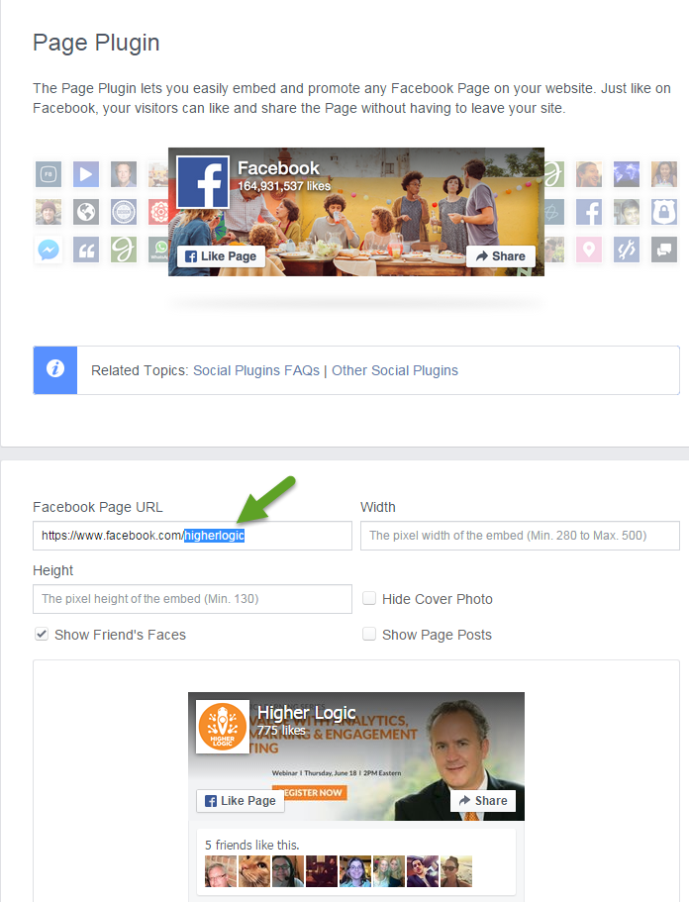

- Customize the width, height, and what to show on the widget
- Click “Get Code”



**Here’s the tricky part so read carefully**

- Create a navigation page named “Facebook” under the slideshow folder in the home dropdown
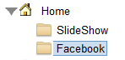
- Click edit, uncheck show title and select “Hide this navigation but leave its content on the site”
  - Name the URL and Page code “facebook”
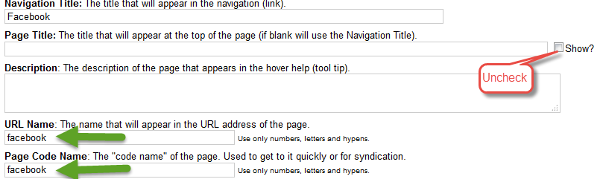
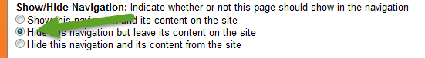
- Create two Javascript content items and name them “Facebook Inline” and “Facebook URL”

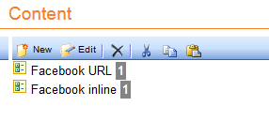

- For the first JavaScript item select “URL of JavaScript file” and put in your Facebook page hyperlink
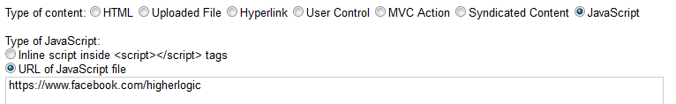

- Go back to the Facebook site where you clicked “Get Code” and copy everything EXCEPT the “<div id=”fbroot”></div> <script>” in the beginning and the “</script>”at the end. In the content item “Facebook Inline”, check the bullet “Inline script inside <script></script> tags” and paste what you’ve copied in the text box. Click save.
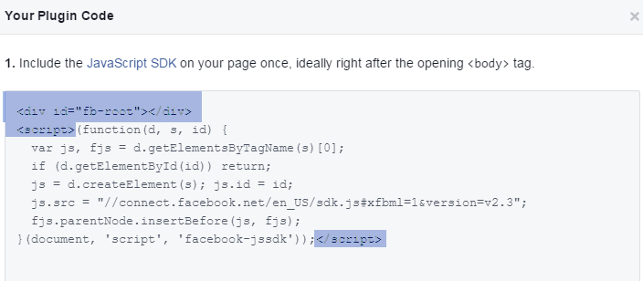

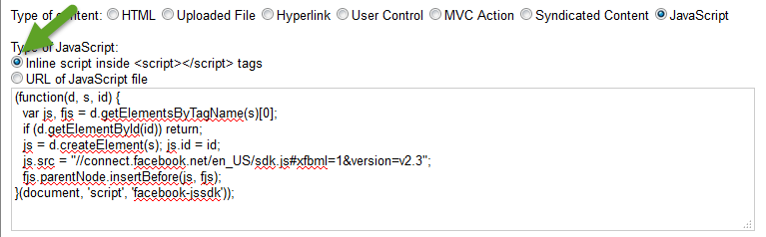

- Go to the home page navigation and create a new content item.
  - Name it “Facebook Widget” and put it in the section you would like the widget to appear.
  - Uncheck the “Show?” box
  - Go back to the Facebook widget site “Get Code” screen
  - Copy the code from number 2 and paste it into the HTML part of your content item. Click Save.
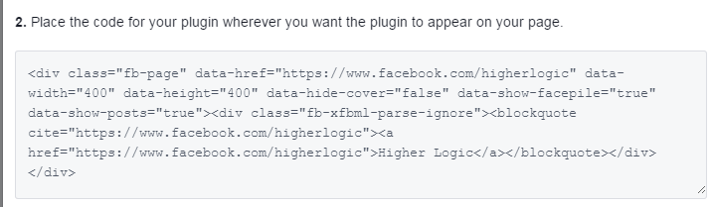
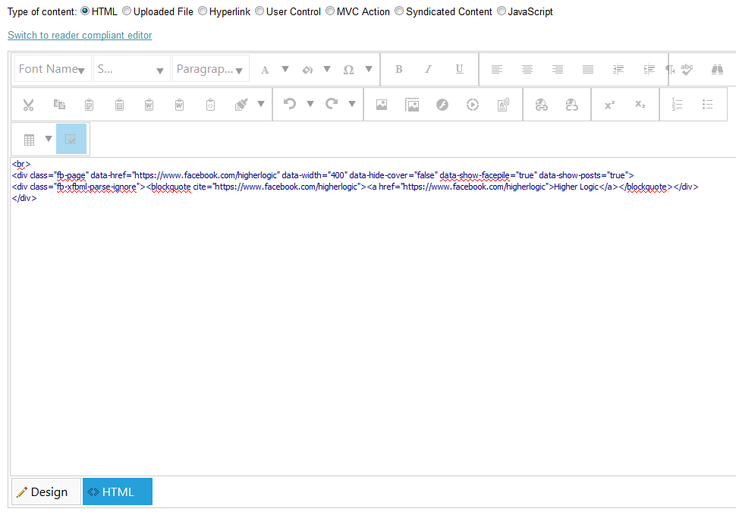

- Lastly, go to Site Setup > Layout > Additional Site-Wide Content
  - Under Header “appearing at the top of the header” choose the “facebook” page you first made. Click finish.

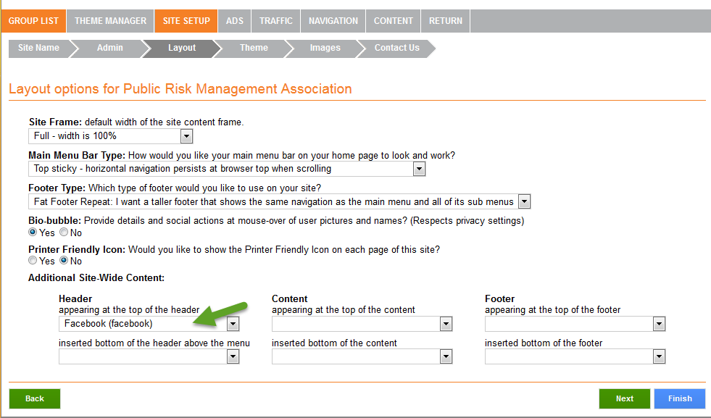
**The widget may take a few moments to show up**

