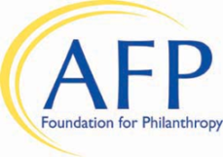
D I V E R S I T Y S C H O L A R S H I P C A M P A I G N

I would like to support the AFP Diversity Scholarship Campaign. I wish to direct my gift*/pledge to:

The General Diversity Scholarship Fund

The Gay, Lesbian, Bisexual and Transgender (GLBT) Diversity Scholarship Fund

The African-American Diversity Scholarship Fund

Details about the Funds can be found on the reverse side of this form.

Name_______________________________________________________ Date____________________
Address__________________________________________________________________________________
City_____________________________ State/Province_______________ Postal Code___________________
Home Phone________________________________ Business Phone_________________________________
Email ____________________________________________________________________________________

Gift* of $ __.

Through my check made payable to AFP Foundation for Philanthropy
Through my credit card (VISA, MasterCard, Discover, or American Express)
Card number Expiration Date _____/_____

Signature ___ Date

Pledge of $ ____ to be paid in payments of $ ______ to be paid by 10/31/2018.
* Gifts paid by October 31, 2018 will count toward and aid in scholarships for the 2019 conference.

Please charge my payments directly to my credit card (VISA, MasterCard, Discover, or American Express) according to my payment schedule:

Payment 1 $ Date Payment 3 $ Date _____
Payment 2 $ Date Payment 4 $ Date _____
Card number Expiration Date _____/_____

Signature ___ Date

Please send me reminders for my pledge during the months circled below.

February March April May June July August September October November December

Please mail your completed form to:  AFP Foundation for Philanthropy  4300 Wilson Boulevard, Suite 300  Arlington, VA 22203-4168 | Or, scan and email your form to foundation@afpnet.org or fax your form to (703) 683-0735. If you have any questions, please contact the AFP Foundation for Philanthropy at (800) 666-3863.

.

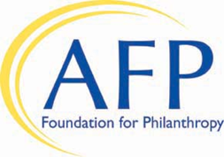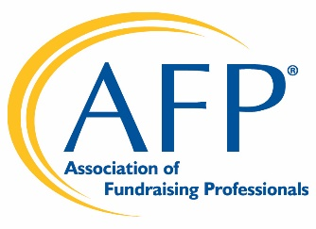

The AFP Foundation for Philanthropy

Advancing Diversity by Establishing a Diverse Profession

A 2018 Joint Strategic Initiative
of
AFP and the AFP Foundation for Philanthropy

As a community of inclusion, the Association of Fundraising Professionals seeks, embraces, and engages diverse individuals, groups, and organizations with a broad representation of experiences, perspectives, thoughts and cultures within the fundraising profession. Through this strategic initiative, AFP is committed to activities that increase awareness of diversity issues. As part of this commitment, the AFP Foundation created a diversity scholarship program to provide financial assistance for professional fundraisers and AFP members who are themselves members of a diverse community, or are employed by grassroots organizations that primarily serve diverse populations.

The AFP Foundation for Philanthropy invites fundraising professionals and AFP members to support diversity within the fundraising profession through the Diversity Scholarship Campaign. Contributions to this campaign will fund scholarships to support registration and travel costs to attend the annual AFP International Conference on Fundraising.

Scholarships will be offered in each of three categories provided the category achieves sufficient funding. The AFP Foundation offers our donors the opportunity to direct their gifts to one of the following categories:

The General Diversity Scholarship Fund – reserved for applicants who identify themselves as members of the AFP diversity community of fundraising professionals.

The Gay, Lesbian, Bisexual and Transgender (GLBT) Scholarship Fund – reserved for applicants who are members of the AFP GLBT diverse community of fundraising professionals.

The African-American Diversity Scholarship Fund – reserved for applicants of the AFP African-American diverse community of fundraising professionals.

