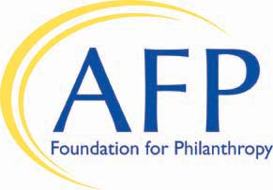
AFP Foundation for Philanthropy
Growth in Giving Initiative Gift/Pledge Form

Name AFP ID
Title
Organization
Address
City State ZIP
Business Phone Cell Phone _______
Home Phone E-mail
Chapter Name ____________

Yes, I will support the Growth in Giving Initiative with a

Gift of $ _________ or Pledge of $ ________

Please choose one of the following fulfillment options:
One-Time Gift Specific Pledge Payment Schedule:

Payment 1 $ Date Payment 3 $ Date _____
Payment 2 $ Date Payment 4 $ Date _____
Please send me reminders for my pledge during the months circled below.
January February March April May June July August September October November December

Payment Method (make a gift or pledge online at www.afpfoundation.org)

Through my check made payable to AFP Foundation for Philanthropy

Through my credit card (VISA, MasterCard, Discover, or American Express)
Card number Expiration Date _____/_____

Return completed pledge form to AFP Foundation for Philanthropy, 4300 Wilson Boulevard, Suite 300, Arlington, VA 22203-4168; scan and email it to foundation@afpnet.org; or fax it to 703-683-0735. Please contact us at 800-666-3863 with any questions.

Thank you for supporting AFP Foundation for Philanthropy. Gifts to the Foundation are tax-deductible to the fullest extent of the law as no goods or services are provided in consideration of a gift (Tax ID #52-1241128). Under the direction of the Board of Directors, the AFP Foundation retains complete control over the use and distribution of donated funds in furtherance of its mission.

