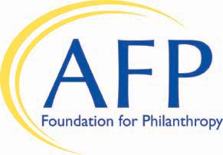
2018 Leadership Academy
AFP Foundation for Philanthropy
Leadership Development Gift/Pledge Form

Name AFP ID
Title
Organization
Address
City State ZIP
Business Phone Cell Phone _______
Home Phone E-mail
Chapter Name ____________

Yes, I will give to the Leadership Academy with a

Gift of $ _________ or Pledge of $ ________

Payment Method (or make a gift or pledge online at www.afpfoundation.org)

Through my check made payable to AFP Foundation for Philanthropy

Through my credit card (VISA, MasterCard, Discover, or American Express)
Card number Expiration Date _____/_____ CVV ______
Please choose one of the following fulfillment options:
One-Time Gift I would like to provide this gift in both 2018 & 2019

Specific Payment Schedule:

Payment 1 $ Date Payment 3 $ Date _____
Payment 2 $ Date Payment 4 $ Date _____

Return completed pledge form to AFP Foundation for Philanthropy, 4300 Wilson Boulevard, Suite 300, Arlington, VA 22203-4168; scan and email it to foundation@afpnet.org; or fax it to 703-683-0735. Please contact us at 800-666-3863 with any questions.

This gift is designated toward the AFP Leadership Development Program and will not count toward the BE the CAUSE Campaign.

Thank you for supporting AFP Foundation for Philanthropy. Gifts to the Foundation are tax-deductible to the fullest extent of the law as no goods or services are provided in consideration of a gift (Tax ID #52-1241128). Under the direction of the Board of Directors, the AFP Foundation retains complete control over the use and distribution of donated funds in furtherance of its mission.

