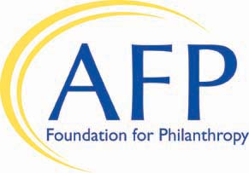

100 Percent Chapter Board Participation Form

For the 2019 BE the CAUSE Campaign

“Lead by Example”

On behalf of the AFP Chapter, I am pleased to announce
that 100 percent of our Chapter’s Board Members have made a commitment to the 2018 BE the CAUSE Campaign
to support programs that advance philanthropy through ethical and effective fundraising.

Foundation Development Chair (please print)

Signature Date

Please return by May 24th for recognition in AFP eWire
Please return by September 13th for recognition at Leadership Academy.
Please return by December 31st for Ten Star Status.

100 Percent Participation Recognition

Chapters that contribute to the campaign will receive the following:
- Recognition in AFP eWire and on the AFP website in the Foundation's online donor recognition lists
- Recognition at Leadership Academy
- Listing in the 2019 Annual Report
- Listing on the Foundation's donor panel at the 2020 International Conference on Fundraising

Email to foundation@afpglobal.org

4300 Wilson Boulevard, Suite 300, Arlington, VA 22203-4168

Toll Free: 800-666-3863 x448

