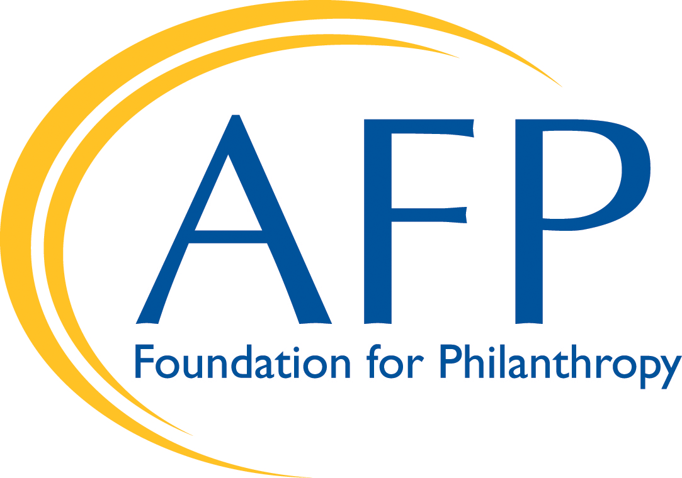
Tiered, Cooperative Annual Fund Distribution Model for BE the CAUSE Campaign (Accepted: January 30, 2015)
For AFP Chapter Leaders

The AFP Foundation for Philanthropy works in partnership with AFP chapters throughout the United States to implement our cooperative annual fund campaign. The Foundation processes and acknowledges 97% of all BE the CAUSE donations; provides donor relations services; and oversees the pro bono calling program. Chapters identify a campaign chair to coordinate fundraising activities within their communities.

The AFP Foundation has adopted processes and procedures to share a portion of the total funds raised with local AFP chapters. The distribution model, enables a 501(c)(3), the AFP Foundation, to distribute funds to another 501(c)(3), an AFP Chapter, with similar missions. Funds are used by both the AFP Foundation and local AFP chapters for education programs, research, and service that benefit those who lead, serve and support nonprofit institutions.

This distribution model illustrates how funds raised by a chapter are allocated between that chapter and the AFP Foundation. It represents the sharing of funds between a chapter and the AFP Foundation and does not constitute a compensation plan. This model is compliant with the AFP Code of Ethical Standards and its prohibition on percentage-based compensation.

2016 Model

Tier | Cooperative Annual Fund Distribution | Criteria
1 | 15% | From first dollar raised
2 | 25% | Meet low-range goal PLUS achieve 100% Board Participation
3 | 35% | Meet high-range goal PLUS achieve 100% Board Participation AND an increase in total funds raised from 2015

FAQs

- What it the rationale behind implementing a tiered distribution model?
- The AFP Foundation is constantly working diligently to develop a culture of philanthropy, trust, and collaboration with U.S. chapters. This is demonstrated through the following significant improvements:
  - The goal-setting process now features a campaign data spreadsheet including prior year results by giving level as well as a gift table for low- and high-range goals;
  - Campaign materials articulate the case for support by providing transparency and addressing common prospect/donor questions;
  - BE the CAUSE, provides chapters with a comprehensive toolkit and various resources to easily implement this cooperative campaign; and
  - The campaign data and toolkit enable the Foundation and chapters to employ best fundraising practice.

- How are the low- and high-range goals set?
- Proposed low- and high-range goals will be prepared by the AFP Foundation based on your chapter’s performance from the previous year and presented to each chapter for board discussion, modification, and acceptance in the form of a campaign data spreadsheet.
- Your chapter can call the Foundation to discuss these goals; our aim is not to impose a goal but to suggest one for your chapter consideration.

- Can you explain the different tiers?
There are three tiers in this distribution model. Our hope is that you and your chapter will be motivated to increase your combined support of the BE the CAUSE campaign while at the same time increasing the distribution amount that will directly come back to your chapter. You can do this by striving toward a tier that’s right for your chapter’s capabilities.

- Tier 1: Receive 15% of your total donations received:
  - Your chapter will automatically receive 15% of the total donations received, less than your low-range goal.
  - Example: If your low-range goal is $3,000 and you raise $2,000 your chapter will receive $300.

- Tier 2: Receive 25% of your total donations received, provided you accomplish the following:
  - Meet or exceed low-range goal PLUS achieve 100% Board Participation.
    - Example: If your low range goal is $3,000 and you raise $3,200 plus achieve 100% Board Participation, your chapter will receive $800.
  - What happens if our chapter does not meet the goal and/or does not achieve 100% Board Participation?
    - Your chapter will receive 15% of the total dollars raised.

- Tier 3: Receive 35% of your total receipts, provided you accomplish the following:
  - Meet or exceed high-range goal PLUS achieve 100 percent board participation AND an increase in total funds raised from 2015.
    - Example: If your high-range goal is $4,500 and you raise $5,000 PLUS you achieve 100 percent board participation AND your chapter has an increase in total funds raised from 2015, your chapter will receive $1,750.
  - What happens if our chapter does not meet the high-range goal and/or does not achieve 100% Board participation and/or does not have increase in total funds raised from 2018?
    - Your chapter will receive 25% of total receipts, if they achieve 100% Board Participation. If not, your chapter will receive 15% of total receipts.

- Do we have to track board giving ourselves?
  - Yes. The AFP Foundation will also track board giving based on all donated received and credited to your chapter by December 31, 2019. Campaign chairs should review this report for achievement of 100% board participation and once all local AFP chapter board members have made a pledge/gift, campaign chairs should complete a 100% board participation form available online.

- When does my chapter receive its distribution?
  - Your chapter will receive notification of its distribution amount by the end of first quarter of the following calendar year (approximate timeframe is the end of March).
  - Your chapter must fill out the simple grant request form. We ask that these forms be completed by June 30th.

- How will my chapter receive its distribution?
  - Chapters will receive a direct deposit or an electronic funds transfer. If that is not possible, then the AFP Foundation will send a check via mail and chapter presidents will be informed.

- Can we use the money for anything we want?
  - Your chapter may use the funds for the following items:
- Education programs and related costs
- Professional development
- Chapter/event speakers
- Educational conferences (ICON, Leadership Academy, etc.) registrations/travel
- Fundraising and/or nonprofit sector research
- NPD / public-facing philanthropic events
- Webinars
- Scholarships for AFP and non-AFP members
If your chapter wishes to use the funds for other purposes not listed above, please contact us to discuss if it qualifies under the AFP Foundations’ funding guidelines.
  - AFP members attending the International Conference on Fundraising can embrace educational opportunities to further their professional education and leadership development with sessions in the following areas:
- Donor & Fundraiser Decision Making
- Science of Fundraising Psychology
- Board Development
- Creative Communication
- Trends for Nonprofits & Public Policy
- Relationship Development
- Technology Trends Shaping Nonprofits

- How are we recognized for participation and giving?
  - There are a variety of ways the AFP Foundation will recognize your chapter and your donors.
    - Chapter Recognition – Chapter IMPACT Campaign
      - Chapters will be recognized in
        - AFP Foundation section of AFP Website
        - Signage at the International Conference on Fundraising and Leadership Academy
    - Chapter Recognition – 100% Board Participation
      - Chapters will be recognized in
        - AFP Foundation section of AFP Website
        - Signage at the International Conference on Fundraising and Leadership Academy
    - Individual Donor Recognition
      - Donors will be recognized by giving level as follows
        - Donor pin ($50+ gifts)
        - Leadership Society donor* – cumulative giving of $10,000+ and a minimum $1,000 annual fund gift
          - Major Donor Reception at ICON
          - Signage at ICON
        - Champions Circle – multi-year commitment of at least $5,000 per year over five years
          - Major Donor Reception at ICON
          - Signage at ICON
        - Omega Circle donor (planned giving)
          - Major Donor Reception at ICON
          - Signage at ICON

Contact: 703-519-8470 | foundation@afpglobal.org

