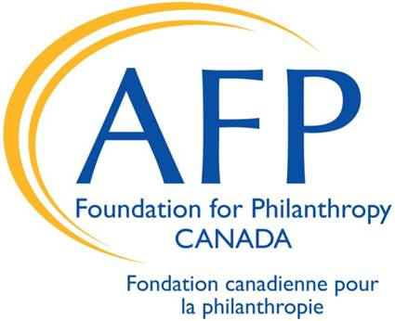
AFP EVERY MEMBER CAMPAIGN
GIVING FORM
Name: |  |  |  | Chapter to be credited:
Language of correspondence: |  | English | Français | AFP ID #

 Please send my tax receipt by email:
 Please send my tax receipt to the mailing address on file with AFP
 Please send my tax receipt to the mailing address below:

❐ I want to join the Alpha Society monthly giving program with an ongoing monthly gift of:
I understand that I may change or cancel my donation at any time by calling the Foundation at 1-800-796-7373

❐ I prefer to make a fixed-term gift of:  |  | Monthly | Quarterly | End date:

❐ I prefer to make a one-time gift of:

Payment information | VISA | MC | AMEX | ❐ Cheque “AFP Foundation for Philanthropy - Canada”
 | Preauthorized debit (please provide a voided cheque)

Credit card number |  | Expiry date

Signature |  | Date

❐ I wish for my gift to remain anonymous
❐ I would like to make this gift in honor of:

AFP Foundation for Philanthropy - Canada  412-260 King Street East  Toronto, ON M5A 4L5 | Phone: 416-941-9144  Fax: 416-941-9013  Email: cdnfoundation@afpglobal.org
Thank you for your support of the AFP Foundation for Philanthropy - Canada.
Gifts to the Foundation are eligible for a tax receipt. Canadian charity number 869811596 RR0001.
"The AFP Foundation for Philanthropy - Canada, respects your privacy and adheres to all legislative requirements and best practices with respect to protecting your privacy. We do not rent, sell or trade our mailing lists. We use the information you provide to us to keep you informed of the activities of the AFP Foundation for Philanthropy - Canada, and for tax receipt and donor recognition purposes. If at any time you wish to be removed from our contact lists or do not want to be included in a donor recognition list, please contact Jill Rankin at (416) 941-9144, (Toll Free 1-800-796-7373) or cdnfoundation@afpglobal.org."

