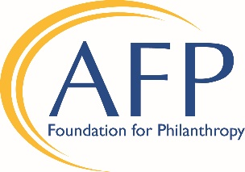

AFP Foundation for Philanthropy
Is pleased to offer
Text to Give
For Your Chapter

You can increase donations to your Be the Cause Campaign

Thanks to our Foundation in kind sponsor give by cell

You can offer Text to Give at all your chapter events, including:

- Your local Conference/Fundraising Day
- National Philanthropy Day®
- Chapter lunches and meetings
- Chapter board meetings

It’s simple to use

- Promote “Text AFP to 571-749-2699” (US Only)
  - Make announcements at your events
  - Include text instructions in your emails
- Gifts will be processed and credited to your chapter
- Text to Give gifts count toward your BE the CAUSE Goal

If you have questions

- Contact Ayat Hassan, Foundation Development Specialist at AFP
- foundation@afpglobal.org
- Direct: +1 (703) 519-8448

Thank you to give by cell for providing this important in-kind gift through December 31, 2019!

