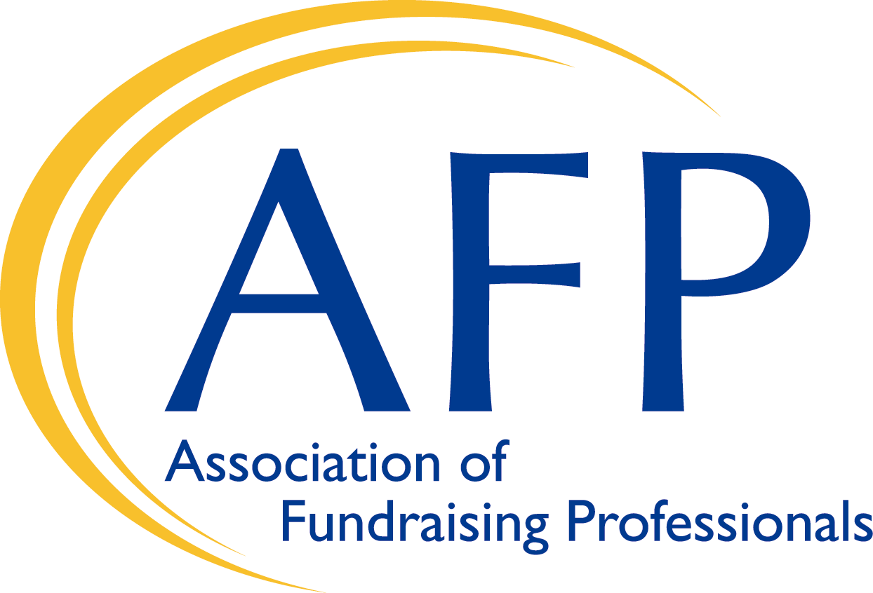
Association of Fundraising Professionals (AFP)
Conference Code of Conduct Policy

Summary
At AFP we assume that most people are well intended, and we are not inclined to tell people what to do. However, we want every AFP conference to be a safe and productive environment for everyone in attendance. To that end, this Conference Code of Conduct policy spells out the behavior we support and do not support at conferences.

The core of our approach is:
We will not condone harassment or offensive behavior, at our conference venues. It is counter to our organizational values. More importantly, it is counter to our values as human beings.

We are voicing our strong, unequivocal support of appropriate behavior by all participants at our conferences, including all AFP events and after conference festivities. Participants are defined throughout this policy to include all attendees, speakers, sponsors, volunteers, AFP staff, contractors and venue support personnel.

We invite you to help us make each AFP conference a place that is welcoming and respectful to all “participants” regardless of race, gender, gender identity and expression, age, sexual orientation, disability, physical appearance, national origin, ethnicity, or religion. So that everyone can focus on the conference itself, and the great networking and community richness that happens when we get together in person, we will not tolerate harassment of conference participants in any capacity either in person or online.

Examples of harassment include offensive comments, verbal threats or demands, sexualized images in public spaces, intimidation, stalking, harassing photography or recording, sustained disruption of sessions or events, and unwelcome physical contact or sexual attention. Harassment also includes slights and negative messages, both unintended and intentional, based solely on appearance (sometimes called microaggressions).

We expect all participants to follow the Conference Code of Conduct during the conference. This includes conference-related social events at off-site locations, and in related online communities and social media. Participants asked to stop any harassing behavior are expected to comply immediately. Participants violating this Conference Code of Conduct may be expelled from the conference without a refund, and/or banned from future AFP events.

Introduction
Most conferences will want several different versions of our Conference Code of Conduct Policy: a short, medium, and long version of the policy for public consumption, and an internal version spelling out implementation for use by the conference organizers and staff.

Short public version
This is a very short version that refers the reader to a longer version of the policy. Suitable for footers on announcement emails, web pages, news stories, etc.

AFP conferences are dedicated to providing a harassment-free experience for everyone, regardless of gender, gender identity and expression, age, sexual orientation, disability, physical appearance, body size, race, ethnicity, religion (or lack thereof), or technology choices. We do not tolerate harassment of conference participants in any form. Sexual language and imagery is not appropriate for any conference venue, including talks, workshops, parties, Twitter and other online media. Conference participants violating these rules may be sanctioned or expelled from the conference without a refund at the discretion of the conference organizers.

Medium public version
This is a statement of the organizers principles and sets expectations for the tone and style of the conference. Suitable for the conference web site location and longer announcements.

AFP is dedicated to providing a harassment-free conference experience for everyone, regardless of gender, gender identity and expression, sexual orientation, disability, physical appearance, body size, race, age or religion. We do not tolerate harassment of conference participants in any form. Sexual language and imagery is not appropriate for any conference venue, including talks. Conference participants violating these rules may be sanctioned or expelled from the conference without a refund at the discretion of the conference organizers.

Long public version
This version focuses on specific instructions to the participants, with the goal of preventing harassment in the first place through education. Suitable for the conference web site and conference program material.

AFP is dedicated to providing a harassment-free conference experience for everyone, regardless of gender, gender identity and expression, sexual orientation, disability, physical appearance, body size, race, age or religion. We do not tolerate harassment of conference participants in any form. Sexual language and imagery is not appropriate for any conference venue, including talks. Conference participants violating these rules may be sanctioned or expelled from the conference without a refund at the discretion of the conference organizers.
Harassment includes, but is not limited to:
- Verbal comments that reinforce social structures of domination related to gender, gender identity and expression, sexual orientation, disability, physical appearance, body size, race, age, religion;
- Sexual images in public spaces;
- Deliberate intimidation, stalking, or following;
- Harassing photography or recording;
- Sustained disruption of talks or other events;
- Inappropriate physical contact;
- Unwelcome sexual attention;
- Advocating for, or encouraging, any of the above behavior.

Enforcement
Participants asked to stop any harassing behavior are expected to comply immediately. Exhibitors in the expo hall, sponsor or vendor booths, or similar activities are also subject to the anti-harassment policy. In particular, exhibitors should not use sexualized images, activities, or other material. Booth staff (including volunteers) should not use sexualized clothing/uniforms/costumes, or otherwise create a sexualized environment.
If a participant engages in harassing behavior, event organizers retain the right to take any actions to keep the event a welcoming environment for all participants. This includes warning the offender or expulsion from the conference with no refund.

Event organizers may take action to redress anything designed to, or with the clear impact of, disrupting the event or making the environment hostile for any participants.
We expect participants to follow these rules at all event venues and event-related social activities. We suggest people should follow these rules outside event activities too.

Reporting
If someone makes you or anyone else feel unsafe or unwelcome, please report it as soon as possible. AFP staff can be identified by special staff badges. Harassment and other Conference Code of Conduct violations reduce the value of our event for everyone. We want you to be happy at our event. People like you make our event a better place. You can make a report either personally or anonymously.

Personal Report
You can make a personal report by contacting a staff member, identified by AFP staff badges.
When taking a personal report, AFP staff will ensure you are safe and cannot be overheard. They may involve other event staff to ensure your report is managed properly. Once safe, we will ask you to tell us about what happened. We will handle it as respectfully as possible. You will not be asked to confront anyone and we will not tell anyone whom you are.

Our team will be happy to help you contact hotel/venue security, local law enforcement, local support services, provide escorts, or otherwise assist you to feel safe for the duration of the event.

