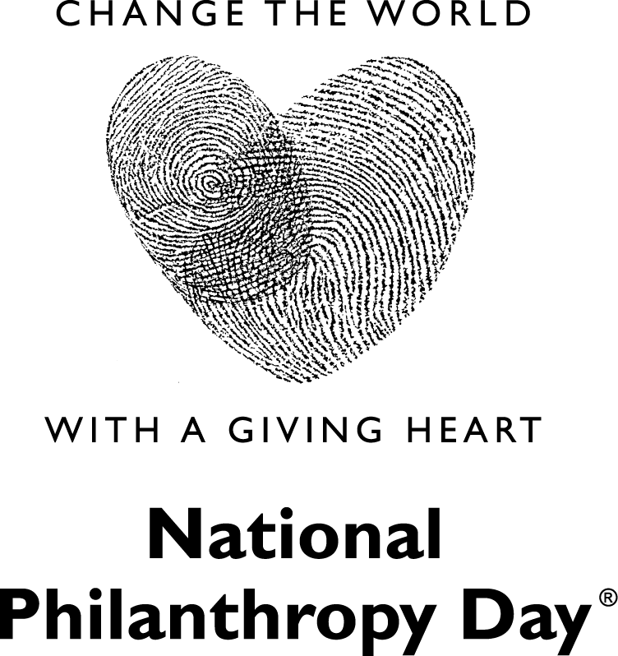
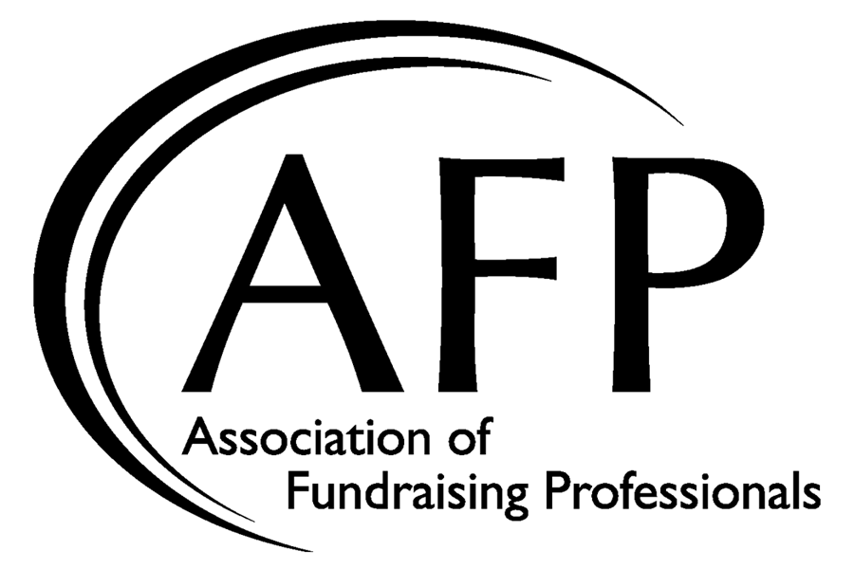

Sample Social Media Posts
It’s November 1, which means we’re not far away from National Philanthropy Day! Set aside to celebrate the impact philanthropy has had on the community, we can’t wait to celebrate. How will you be celebrating #NationalPhilanthropyDay?
National Philanthropy Day is just around the corner. This month, our chapter will be doing/hosting [CHAPTER EVENT] to celebrate the impact of philanthropic contributions. Without philanthropy, change would not be possible, and we can’t wait to celebrate.
Organized in the 1980s, National Philanthropy Day is a special day to recognize & celebrate the societal contributions of philanthropy. This month, [CHAPTER NAME] is celebrating by doing/hosting [CHAPTER EVENT]. Want to celebrate #NationalPhilanthropyDay with us? Click here for more info: [LINK]
Today is a special day. It’s National Philanthropy Day! Set aside to recognize the impact philanthropy has had on society, #NationalPhilanthropyDay let’s us celebrate the change we’ve made, the change we’re making, and the change that is yet to come.
National Philanthropy Day is finally here! Organized in the 1980s, this day is significant in recognizing the important role philanthropy has had on societal change. Today especially, we celebrate the change we’ve made, the change we’re making, and the change that is yet to come. #PhilanthropyDay

