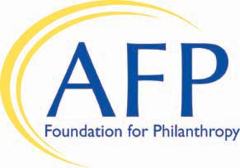
AFP Foundation for Philanthropy
2019 Chapter IMPACT Campaign
Gift/Pledge Form

Chapter Name _________________ ________ ______

Yes, our chapter will support the AFP Foundation for Philanthropy’s 2019 Chapter IMPACT Campaign with a

___ Gift of $ ________ OR ___ Pledge* of $ __ ________ (to be paid by 12/31/19)

Choose one or more of the areas below you wish to support and allocate accordingly (unallocated gifts will be used where they are needed most)

___ Capacity Building $ _________________

___ Diversity & Inclusion $ ______________

___ Leadership Development $ ______________

___ Scholarships $ ____________

Payment Method

___ Check made payable to AFP Foundation for Philanthropy

___ Credit card (VISA, MasterCard, Discover, or American Express)

Card number Expiration Date __

*If making a pledge, please select one of the following options and sign on the line below

___ Charge the credit card in the month of _____________ OR Send an invoice in the month of _____________

Signature ____________ Date _______

Return this form via
- Email: foundation@afpglobal.org
- Fax: 703-683-0735
- Mail: AFP Foundation for Philanthropy, 4300 Wilson Boulevard, Suite 300, Arlington, VA 22203-4168

Questions: Call 703-519-8448

Chapter Impact Campaign Recognition:
- AFP Foundation’s Website
- AFP’s eWire
- AFP’s 2019 Leadership Academy – if gift/pledge is received by September 13, 2019
- AFP’s 2020 International Fundraising Conference

Gifts to the Foundation are tax-deductible to the fullest extent of the law, as no goods or services are provided in consideration of a gift.

Thank you for supporting the AFP Foundation for Philanthropy.

