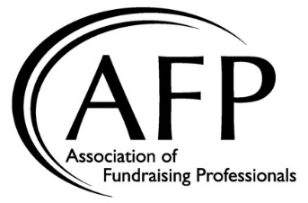

Like Size Group 4 Meeting Notes
Thursday, October 3
1:00 – 2:45 PM

- AFP Core Courses
  - Donor Retention was a well-received program
  - Seeing a decline of core courses on CFRE since they can download sample tests from CFRE
  - CFRE will have a test prep course coming out – AFP will do pilots on this when ready
  - Cost is way too high and that’s why people aren’t coming
  - One Chapter does fundraising 101 and 102 – 30-50 people go to that and they charge $150 for day long program
  - How can AFP be the leader in this content ?
- Board Governance/Succession
  - Offer give away to allow people to volunteer to help
  - Have chairs and co-chairs, co-chairs don’t serve on the board but are expected to move into the chair position the following year on the board
  - Have a scholarship for some of the folks that have higher demanding roles
  - Board expectation spreadsheets is part of the recruitment process
  - Don’t be afraid to have challenging conversations and making hard decisions when people don’t follow through with their responsibilities
  - Governance committee and volunteer placement is a big role that they have
  - NPD committee operates outside of the board besides one high level role that reports to the board
- Membership
  - Coffee chats are a way to help get people engaged in fundraising and engages both current and new members
  - Sometimes it’s hard to get folks to become members but they find it easier to focus on non-dues revenue
  - Young professionals are dropping off membership after age 31
  - Do the best to promote the payment plan for members, specifically when they drop off the young professional status
  - We need to do a better job at conveying a value proposition
- Inclusivity, Diversity, Equity & Access
  - There are a lot of resources on the AFP Resource Guide
- Scholarships
  - Re evaluated the scholarships and what they went to
  - How do we refocus our scholarship programs to focus on recognition and not need of money
  - Scholarship winners are a great marketing opportunity – making folks write articles about their experience
- Education and Programming
  - At the annual meetings, they loved doing speed topics and it added a lot of value
  - Cocktails and calamities - $10 and 9 people share calamities in their careers
  - Book club that they do one per quarter
  - Started an RFP Process for each month of the year, plan and it helps
  - Change location for each program and never pay for a site, usually hosted with local non profits
  - Created SNAP: Seasoned Network of Advancement Professionals (for higher level members)
  - Enhanced and New experience at luncheon that adds a deeper level to their lunch experience
- National Philanthropy Day
  - The awardees should be a big part of the marketing of NPD
  - They have one person that is the liaison between those people and award winners
  - Use a community committee to select the award winners
  - Overlay IDEA across the award nomination and selection process
- Be The Cause
  - Lot’s of folks don’t want to give to international and they have lost donors because of that

