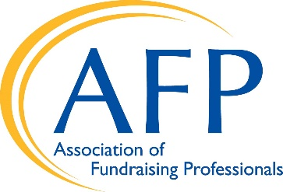
Postage Rates Increases/Postal Reform

With the enactment of the landmark Postal Accountability and Enhancement Act of 2006 (PAEA), nonprofit organizations faced a relatively stable situation in terms of postal rate increases. Specifically, the PAEA limited price increases to a formula derived from the Consumer Price Index (CPI). In most years since 2006, postal rates increased approximately at the rate of inflation, a relatively predictable and reasonable rate of increase.
However, under the 2006 law, the Postage Rate Commission was given the task of conducting a ten-year review of the law’s effectiveness. The PRC finally concluded the USPS’s poor financial situation was due primarily to the CPI cap. It therefore proposed a new regulation, formally adopted in December 2020, which gave new ratemaking authority to the USPS—NOT limited by a cap on the CPI. Nonprofit mailers now face a much more challenging environment of substantially larger rate increases year after year.

New Increases
The Postal Service is expected to announce rate increases of 6.0% to 8.5%, depending on the class of mail, that will be implemented in the summer or fall. This pending rate increase is in addition to the 1.5% rate increase that just took effect on January 24, 2021.
The long-range consequence of the new rate-making authority and the Postal Service’s financial condition could mean crushing increases over the next 4-5 years.
These increases will hit nonprofits hard, especially when our budgets and services have already been affected by the impact of the COVID-19 pandemic. Nonprofit and social organizations rely on the USPS to communicate with our constituents, donors, and potential donors.
Ideal for the nonprofit sector—and all mailers—would be a return to the original goals of the Postal Reform Act of 2006: predictable rate increases, largely in line with the rate of inflation.

Please contact Postmaster General DeJoy and the USPS Board of Governors
and urge them to postpone any major rate increases until 2022!

