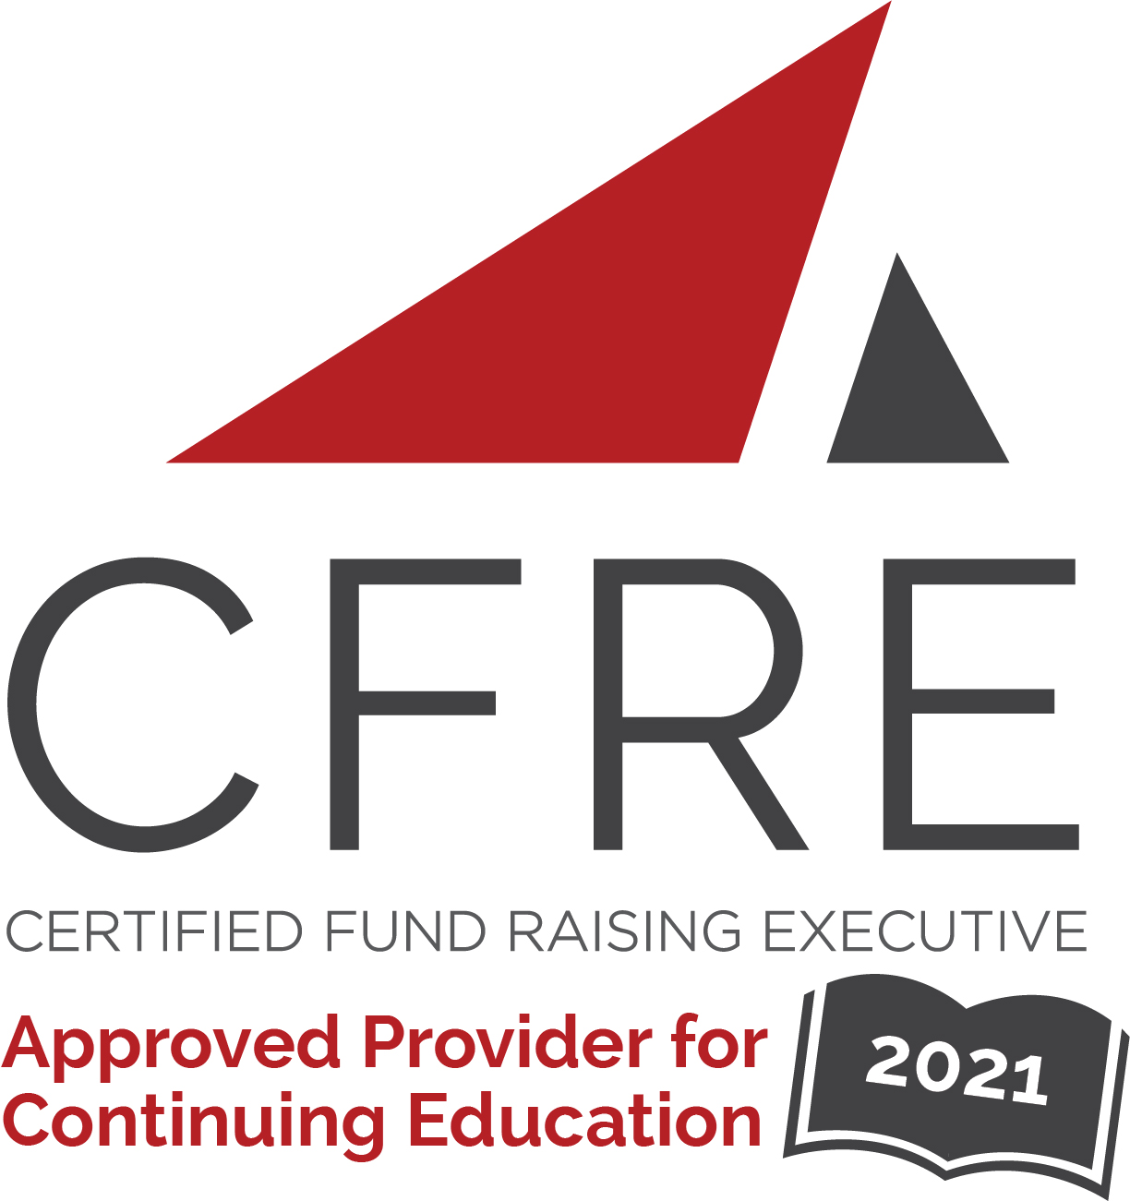  CFRE International has developed this form as a way for you to quickly track (and keep in your files!) the continuing education sessions you have attended. Simply check the boxes next to the sessions you attended. At the end of the conference, add up the total number of hours. Keep this sheet and you will be ready to complete your application form. All of the session slots listed are eligible for continuing education points on your CFRE application for initial certification and/or recertification. Sessions not listed here are not eligible for points. |  | CONTINUING EDUCATION POINTS TRACKER

Activity Organizer: - AFP International
Title of Activity: - AFP LEAD 2021
Names of Presenter(s): - Various
Dates and Location: - October 18-20, 2021, Indianapolis, IN

Date: Monday, October 18, 2021
Session 1: 9:00 [am] – 12:00 [pm] (3 pts)
- [Masterclass for Young Professionals]

Date: Monday, October 18, 2021
Session 2: 11:00 [am] – 12:00 [pm] (1 pt)
- [Navigating Your Truths During COVID-19]

Date: Monday, October 18, 2021
Session 2: 1:00 [pm] – 5:00 [pm] (4 pts)
- [Mentorship, Workplace Sponsorship and Coaching for Young Professionals]
- [Expert Leadership Toolkit for New Leaders]

Date: Tuesday, October 19, 2021
Session 1: 10:45 [am] – 11:45 [am] (1 pt)
- [The Promise of Breaking Bias]
- [Prioritizing Mental Health & Wellness in the Workplace: The Time is Now for Nonprofit Leaders]
- [Prioritizing Donor Relationships]

Date: Tuesday, October 19, 2021
Session 2: 1:45 [pm] – 2:45 [pm] (1 pt)
- [Finding Calm in Chaos Advocating for Resources to Create a Winning Strategy]
- [But We Never Left: How Return to Work will Affect the Way We Lead]
- [Be a More Effective Nonprofit Leader by Using More Effective Communication]
Date: Tuesday, October 19, 2021
Session 3: 3:00 [pm] – 4:00 [pm] (1 pt)
- [Listening and Flexibility: What are the Keys to Finding and Retaining Top Talent in a COVID and post-COVID World]
- [How to Build a Collaborative Culture Where Everyone Shines]
- [Building a Leadership Pipeline]

Date: Tuesday, October 19, 2021
Session 4: 4:15 [pm] – 5:15 [pm] (1 pt)
- [Radical Intentionality: Required to Change the Lived Experience of Marginalized & Radicalized Fundraisers]
- [The Accountable Nonprofit: Essential Financial Management Skills]

Date: Wednesday, October 20, 2021
Session 1: 8:30 [am] – 9:30 [am] (1 pt)
- [Fix Bias, Not People: Ending Imposter Syndrome Through Embracing Diversity in Leaders and Leadership Styles]
- [Becoming Your Organization’s Ultimate Brand Ambassador]
- [Building Better Boards… Your Role in Supporting, Motivating, and Moving Board Members to Action]
- [How to Differentiate Yourself and Maximize Impact by Embracing New Technologies]

Date: Wednesday, October 20, 2021
Session 2: 9:45 [am] – 10:45 [am] (1 pt)
- [Remotely Normal: Building Camaraderie While Living and Working in Different Cities (and Continents)!]
- [7 Rules of High Self-Esteem for Leaders and Managers]
- [Leading a Multi-Generational Team: How to Recruit, Retain, and Inspire]

Date: Wednesday, October 20, 2021
Session 3: 11:00 [am] – 12:00 [pm] (1 pt)
- [The Great Me-Set]
- [Managing Up Start with IDEA and Build Solid Connections]
- [I’ve Been Promoted, Now What]
- [The Responsive Mindset: How to Build Resilient Teams & Drive Growth With Confidence]

Date: Wednesday, October 20, 2021
Keynote: 1:15 [pm] – 2:00 [pm] (1 pt)
- [Tyrone Freeman]

Total number of points attained: __________

