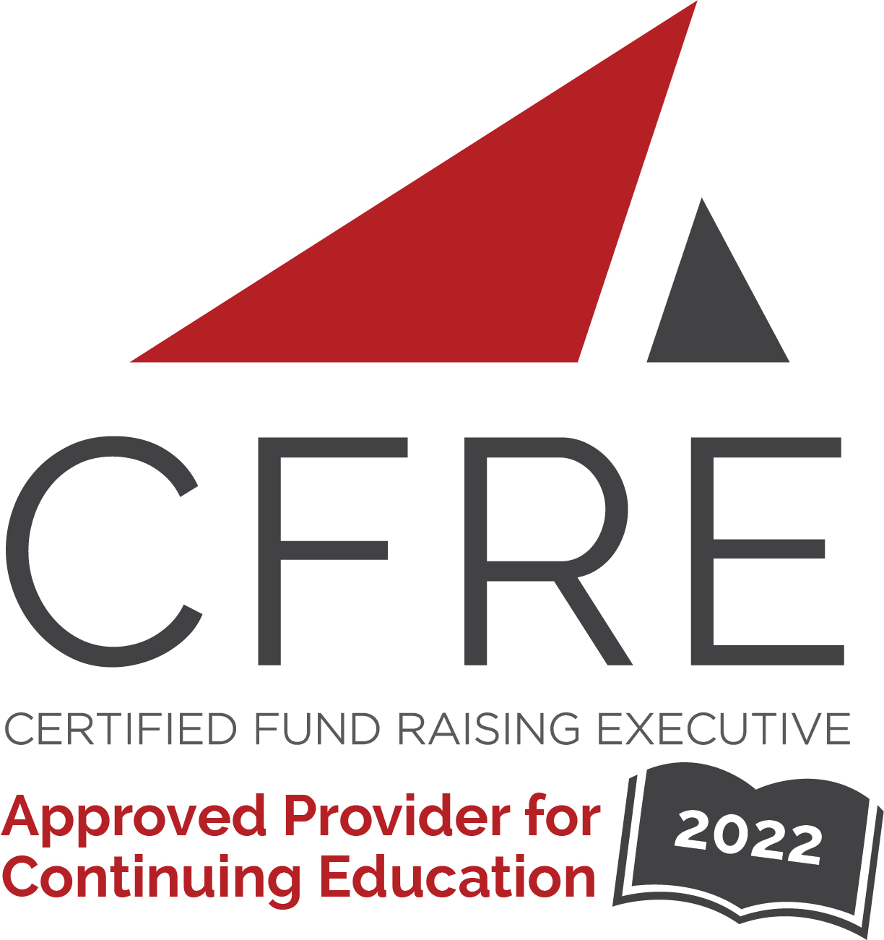  CFRE International has developed this form as a way for you to quickly track (and keep in your files!) the continuing education sessions you have attended. Simply check the boxes next to the sessions you attended. At the end of the conference, add up the total number of hours. Keep this sheet and you will be ready to complete your application form. All of the session slots listed are eligible for continuing education points on your CFRE application for initial certification and/or recertification. Sessions not listed here are not eligible for points. |  | CONTINUING EDUCATION POINTS TRACKER

Activity Organizer: - AFP International
Title of Activity: - AFP LEAD
Names of Presenter(s): - Various
Dates and Location: - 20-22 October, 2022 – Houston, TX

Date: 20 October, 2022
Session 1: 10:00am – 10:45am (1 pt)
- Coaching, Mentorship & Workplace Sponsorship for Professionals

Date: 20 October, 2022
Session 2: 11:00am – 11:45am (1 pt)
- Pivot, Adapt, Refocus: Career Growth and Fundraising Through Adversity

Date: 20 October, 2022
Session 3: 1:30pm – 3:30pm (2 pts)
- Landing (or Keeping) Your Dream Job: A Career Success Roadmap

Date: 21 October, 2022
Session 1: 10:45am – 11:45am (1 pt)
- Bamboo vs. Bonsai: Applying and Creating an Organizational Entrepreneurial Mindset
- IDEA: Moving the Fundraising Community Forward
- The Leadership Factor: Why Some Fundraising Professionals Always Succeed
- Advocacy in the Nonprofit Sector: What, Why, and How

Date: 21 October, 2022
Session 2: 1:45pm – 2:45pm (1 pt)
- Leading to Inspire Joy in Your Development Team
- How to Maximize Your Employee Engagement
- How to Succeed with Succession Planning
- How to Leverage Strategic Alliances for Optimal Financial Management
- Preparing Your Nonprofit for Growth and Success: Lessons Learned from a High Growth For-Profit

Date: 21 October, 2022
Session 3: 3:00pm – 4:00pm (1 pt)
- The Lonely Road to Leading
- The Urgency of Now: We Need a New Approach to Planning
- Embracing I.D.E.A. During Hiring: What Nonprofits Can Learn From My Job Search
- Prospecting Perfection: Organize Your Portfolio for Optimal Results
- The Paradox of Leadership

Date: 22 October, 2022
Session 1: 9:00am – 10:00am (1 pt)
- How to Handle Conflicts Like an Empath (and Strengthen Your Team in the Process)
- Fostering a Culture of Gender Inclusion in Fundraising and Nonprofit Spaces
- Shift Happens: How Gratitude will Improve Your Fundraising and Your Life
- Why Bother: Leadership Starts Within
- Leadership 2.0 Discovering Your Authentic Leadership Style

Date: 22 October, 2022
Session 2: 10:15am – 11:15am (1 pt)
- More than a Seat at the Table: Engaging Marginalized Communities in Program Design and Implementation
- Speak Like a Leader: The Secret Language of Leaders
- The Big Secret to Public Policy & Lobbying: Every Fundraiser is a Natural Advocate
- How to Deal with Sexual Harassment in the Fundraising Profession

Date: 22 October, 2022
Session 3: 12:45pm – 1:45pm (1 pt)
- How to Hire Authentic Leaders to do Transformational Work
- Combat Leadership Lessons for Fundraising Professionals
- From Silos to Collaboration: Grant Management for Team Building
- It’s Time to Elevate
- Culture Shift: Small Changes That Make a Big Difference in Workplace Culture

Total number of points attained: __________

