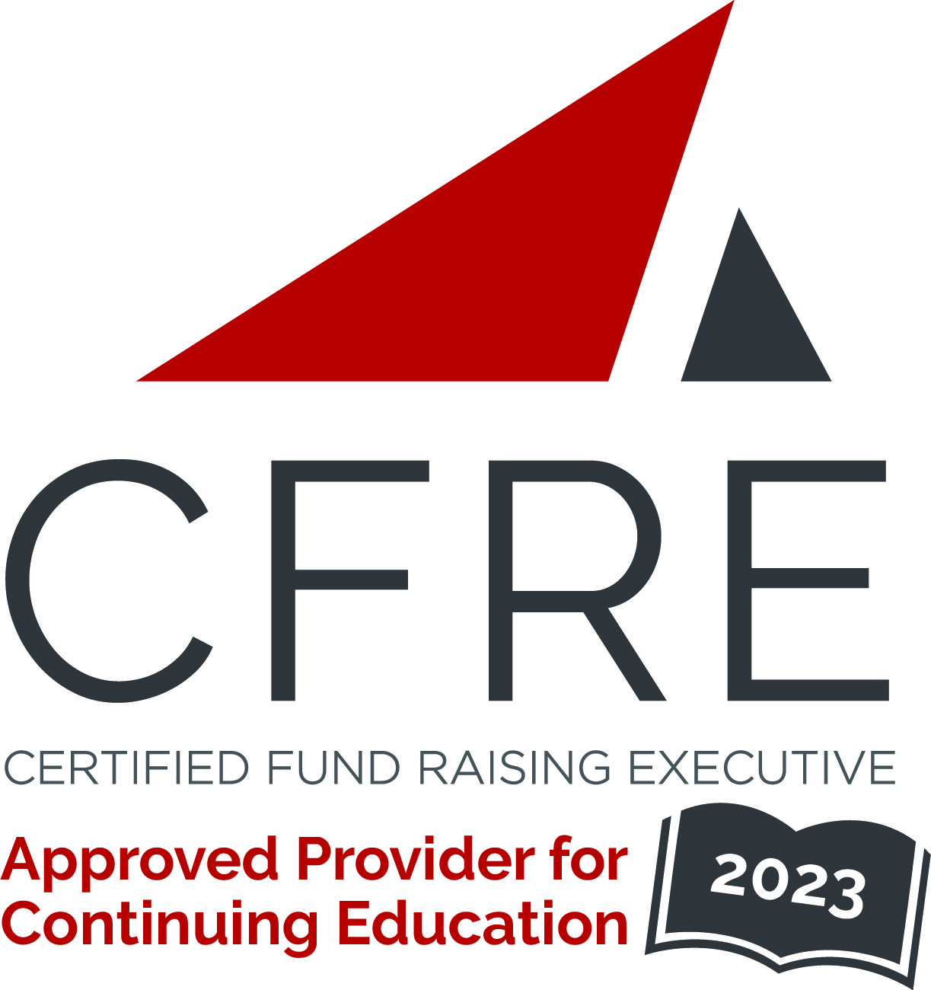  CFRE International has developed this form as a way for you to quickly track (and keep in your files!) the continuing education sessions you have attended. Simply check the boxes next to the sessions you attended. At the end of the conference, add up the total number of hours. Keep this sheet and you will be ready to complete your application form. All of the session slots listed are eligible for continuing education points on your CFRE application for initial certification and/or recertification. Sessions not listed here are not eligible for points. |  | CONTINUING EDUCATION POINTS TRACKER

Activity Organizer: - AFP International
Title of Activity: - AFP ICON 2023
Names of Presenter(s): - Various
Dates and Location: - April 14 – 18, 2023, New Orleans, LA

Date: Friday, April 14, 2023
Session 1: 8:00 [am] – 5:30 [pm] (8 pts)
- [Pre-Conference Deep Dive: Creating Engaging Donor Journeys that Lead to Legacies DAY 1]
- [Pre-Conference Deep Dive: CFRE Refresher Day 1]
- [Pre-Conference Deep Dive: Fundamentals of Fundraising Day 1]

Date: Saturday April 15, 2023
Session 1: 8:00 [am] – 5:30 [pm] (8 pts)
- [Pre-Conference Deep Dive: Inspire, Ask and Repeat Transformational Giving! YES! I Want More Major Gifts!]
- [Pre-Conference Deep Dive: Donor Retention: A Self-Assessment Workshop]
- [Pre-Conference Deep Dive: Capital Campaign Fundraising: Ready, Set, Go!]
- [Pre-Conference Deep Dive: Creating Engaging Donor Journeys that Lead to Legacies DAY 2]
- [Pre-Conference Deep Dive: The Decision Science Laboratory - Applying Science to Solicitation]
- [Pre-Conference Deep Dive: CFRE Refresher Day 2]
- [Pre-Conference Deep Dive: A Development Professionals Guide to Human Resources]
- [Pre-Conference Deep Dive: CFRE Refresher Day 2]
- [Pre-Conference Deep Dive: Fundamentals of Fundraising Day 2]

Date: Sunday, April 16, 2023
Session 1: 9:00 [am] – 10:15 [am] (1.25 pts)
- [Amplifying Impact Through Workplace Giving]
- [Because Fundraising Isn’t Challenging Enough: Spanning Recent Global Changes in the Law Impacting Philanthropy]
- [Creating a High-Performance Environment for Major Gifts]
- [Facets of Advancement Services: Avoiding Silos in the Pursuit of Institutional Advancement]
- [Fundraising Alchemy: The Science and Art of Integrated Campaigns]
- [Fundraising Possibilities the Pandemic Taught Us]
- [Grow Your Planned Giving Pipeline More Quickly and Efficiently by Re-thinking Donor Outreach]
- [Mid-Level, Sustainer, and Sophisticated Direct Response: How to Adapt to Shifting Donor Expectations]
- [Managing Up: Turning Your CEO into a Fundraising Rock Star]
- [No Need for Drano- Learn How to Unclog Your Donor Pipeline Today]
- [Shifting the Donor Landscape Paradigm: Strategies to Increase Engagement and Philanthropy among Donors of Color]
- [Staff Complacency: The Leadership Blindspot that Demands Attention]
- [The Future of Fundraising: Why Philanthropy is in Trouble– and How to Save It]
- [The Multicultural Majority: Who They Are and How They Are Changing Fundraising]
- [Trends to Diversify Revenue Streams and Raise More Amid Economic Upheaval]
- [Insights From the 2023 Digital Outlook Report]

Date: Sunday, April 16, 2023
Session 2: 10:45 [am] – 12:00 [pm] (1.25 pts)
- [An Introduction to Latinx Fundraising]
- [Are your leaders leading fundraising?]
- [A Tale of Two Campaigns...and How the One that Failed Led Us to Future Success!]
- [Design Fresh Messaging: How to get the best thinking out of your development team]
- [Donor Pet Peeves and How to Address Them]
- [Establish, Grow or Reignite Gift Planning in Your Organization]
- [Facing The Dementia Dilemma Together: Collaboration between Charitable Gift Planners and Financial Planners]
- [Fundraising Innovation: How Canadian Organizations are Leading the Way]
- [Getting Your ~$30: Maximizing the Potential of Your Volunteers]
- [It Starts With a Big IDEA: Values Alignment in Fundraising]
- [The Art of Collaboration]
- [The Secrets of Successful Succession Planning]
- [The Value of the Golfer Donor]
- [Trauma-Informed Fundraising - Understanding Your Role and the Donors]
- [Uncomfortable Conversations]
- [Design Fresh Messaging: How to get the best thinking out of your development team]
- [Six Key Factors for Optimizing Healthcare Philanthropy]

Date: Sunday, April 16, 2023
Session 3: 4:00 [pm] – 5:15 [pm] (1.25 pts)
- [Using Data to Maximize Donor Efficiencies Leading Up to a Campaign]
- [Obstacle schmobstacle! How to go over, under, around, and through to get your YES!]
- [Meet Today’s Donors: How Self-Curated Giving Experiences Are Transforming Fundraising]
- [Inclusive Philanthropy: Who Gives, How, and With What Impact]
- [Governance as Leadership: A Guide to a Generative Thinking Board]
- [Fundraising Action Planning]
- [Faith & Fundraising: Three traditions, Unlimited Questions]
- [Elevate your next Event with a Phenomenal Guest Experience]
- [Don't Judge a Book by Its Cover: Unlock the Value of Every Donor]
- [Doing it All: How the Mental Load of Motherhood Impacts and Inspires How We Fundraise]
- [Digging for Gems: Using Portfolio Reviews and Donor Research to Get to the “YES!”]
- [Being A Black Male In Fundraising-The Conversation Continues]
- [A Stakeholder Management Process for Ethical Fundraising]
- [The 2023 Fundraisers Outlook: 6 Strategic Themes to Drive Your Fundraising Success]
- ["To Affinity and Beyond: Building a Caring, Engaged Community with Fundraising Intelligence]
- [Building Pipeline Through Engagement]

Date: Monday, April 17, 2023
Session 1: 8:00 [am] – 9:15 [am] (1.25 pts)
- [Short staff? Don’t be Cheap... It’s too Expensive!]
- [Stewarding Planned Donors]
- [Are They Feeling The Love? Using Love Language to Build Donor Identity and Wellbeing]
- [Beyond Sponsorship: Winning Strategies for Driving Impact through Corporate Partnership Innovation]
- [Developing a Gift Acceptance Policy That Aligns With Organizational Values]
- [From the Mailbox to the Living Room – Creating an inspiring donor journey]
- [Implementing JEDI Strategies into Fundraising Systems: Values in Action]
- [Making Sense of Fundraising: A Fundraiser's Guide To What's Working in 2022 And Beyond]
- [Making the Ask- using (neuro)science in your solicitation]
- [Looking Overseas for Fundraising Opportunity at Home!]
- [Our New Normal: Fundraising in a Post-Pandemic World]
- [ROI of Strategic Action Planning: Preparing Teams to Dramatically Increase Impact and Revenue]
- [The Future Is Digital: Learnings From The 2023 Nonprofit Acceleration Report]
- [Don’t Let the Donor Die at the Destination]

Date: Monday, April 17, 2023
Session 2: 10:15 [am] – 11:30 [am] (1.25 pts)
- [Solving the Childcare Crisis in the Nonprofit Sector] NFR
- [A Narrative for Professional Fundraisers]
- [Activating an Equity-centered Development Department]
- [Challenges and Opportunities: Trends and Innovations Impacting Fundraising Worldwide]
- [Deliberate Design for Successful Board Governance & Composition: A Case Study]
- [Digital Philanthropy: Relationship-Building through Online Fundraising Strategies]
- [Donor Acquisition vs Donor Retention: Where to focus your money]
- [From Practice to Research to Practice]
- [How to Plan an Effective Capital Campaign Using New Tools and Technology]
- [How to Align Donor’s Heart and Mind With Our Fundraising Desires]
- [Leading Up: The Unique Influence of Fundraisers]
- [Objection! How to Address Donors Legacy Giving Concerns]
- [Pulling the Heartstrings - Telling Your Story Effectively]
- [Visualizing Data for Prospect Identification and Donor Metrics]
- [Trauma-Informed Fundraising - Understanding Your Role and the Donors]
- [Outside the Box Engagement]

Date: Monday, April 17, 2023
Session 3: 1:15 [pm] – 2:30 [pm] (1.25 pts)
- [Allyship and Accessibility in the Disability Sector - Mistakes Made, Lessons Learned and Best Practices]
- [Are You a Buffalo or a Cow? Lessons in Turning Adversity into Trust]
- [Belonging and Exclusion: Creating Space for Growing LGBTQ Donors]
- [Cultivating Fundraisers: Innovative Approaches for Building Your Team]
- [Fostering a Culture of Gender Inclusion in Fundraising and Nonprofit Spaces]
- [Future of Fundraising Now - Fundraising Internationally]
- [Making the Ask Authentically]
- [Manage Up! Techniques for Driving Cross-Team Efficiency in Grant Seeking]
- [New Donors, Demographics & Opportunities: Reimagining Donor Engagement in the Post Pandemic World]
- [Philanthropic Justice: Loving Humanity in Its Fullness]
- [Racial Equity in the Fundraising Profession]
- [Start Your Plan Here: Implementing a Big-League Relationship Management Program for Your Small Shop]
- [Subscription GivingSM - A New Revenue Stream to Your Fundraising Strategy]
- [The Unexpected Failure of Traditional Recognition in Social Media Fundraising – Why It Won’t Work]
- [Donor Magnetism: How to Create Messages that Attract and Retain Donors]
- [Elevating Your Organization’s Vision]

Date: Monday, April 17, 2023
Session 4: 3:00 [pm] – 4:15 [pm] (1.25 pts)
- [A (Cis) Man’s Place Is in This Session: No, Really, Come to This Session] NFR
- [Avoiding Campaign Calamities]
- [Becoming an antiracist learning community]
- [Breaking the Generational Divide - A Key to Legacy Success]
- [HEARD: How to Become a Better Leader - and Fundraiser - Through Active Listening]
- [How to Create an Integrated and Inclusive Development and Communications Plan]
- [How We're Transforming Our AFP Chapter Through a Commitment to IDEA]
- [How You Can Gather Focus Group Data That Will Drive Your Work]
- [It's Deductible! Keeping the IRS and Your Donors Happy]
- [Laissez les bons temps rouler! Building Your Organization’s Dream Team to Secure that Big Gift]
- [Road Map for Big Donors: Secrets From How Raise Millions Dollars]
- [Understanding Donor-Advised Fund Giving Patterns and How to Customize Your Solicitation Strategy]
- [The Promise and Perils of ChatGPT for the Nonprofit Sector]
- [Ten Ways To Support Mental Health and Wellbeing At Work]
- [Stewarding Sustaining Donors]
- [A Culture For Philanthropy]
- [Elevating Your Organization’s Vision]
- [Building Bridges: How to Engage Your Supporters with Peer-to-Peer Fundraising]
- [Interested in the ACFRE Credential?] NFR

Date: Tuesday, April 18, 2023
Session 1: 8:00 [am] – 9:15 [am] (1.25 pts)
- [What Funders Want]
- [Staffing Your Fundraising Operation: Structure, Attract & Retain]
- [Moving Beyond Bricks and Plaques: New Perspectives on Building Inclusive Naming and Recognition Practices]
- [Mid-Level Donors: Key Strategies In Stewarding, Engaging, Soliciting And Upgrading]
- [How to Prioritize (Way!) Better in Fundraising]
- [Getting Your Organization Prepared Before Launching Any Campaign]
- [Board Engagement & Fundraising: Evidence-Based Practices that Work!]
- [Building Donor Loyalty: What Is New From Research]
- [“Fundraising is life” how to reenergize yourself and your fundraising]
- [4 Pillars of Social Media Engagement for Fundraisers]
- [2023 Top Nonprofit Challenges and How to Overcome Them]

Date: Tuesday, April 18, 2023
Session 2: 10:15 [am] – 11:30 [am] (1.25 pts)
- [To Infinity and Beyond Moves Management]
- [The Roots Run Deep: Disrupting Institutional Racism & Unethical Behavior As a Leader]
- [Responsive Nonprofits: How To Build Resilient Teams & Drive Sustainable Growth]
- [Purposeful Organization Growth]
- [Planned Giving for People Who are New to Planned Giving]
- [Pathway to Philanthropist: How FIU is Redefining Charitable Giving]
- [Mystery, Tragedy, Fantasy, Adventure. . . Are You Telling Your Board the Right Fundraising Story?]
- [Innovation, Scientists, Experiments, and Pilot Projects....Oh My! Fundraising for Research]
- [Houston, we have a problem. Ten Reasons Why You Need a Crisis Management Plan.]
- [From Young Pro to Emerging Leader: How to Maximize AFP to Build Your Career!]
- [Donor Advised Funds, Community Foundations, and You: Working Together to Grow Philanthropy]
- [Cognitive Impairment in Donors: Are You Prepared?]
- [2022 Fundraising Effectiveness Project: Using AFP’s Donor Giving Data to Improve Your Fundraising Results]
- [Marketing + Fundraising: A Collaborative Framework That Builds Community & Funding Growth]
- [Peer-to-Peer Fundraising: How to mobilize your donors and build a thriving community]

Total number of points attained: __________

