NOTE TO CHAPTERS:
Please feel free to take any or all of the information contained in this sample document to use in a press release you can distribute to local media. There are places, highlighted in bold, where the chapter can add its own information or include a quote from its leadership. Chapters can make whatever edits or changes they would like. If your chapter has a specific AFP chapter logo, please utilize that logo.

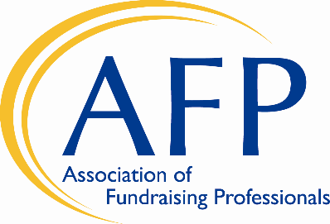

AFP [CHAPTER NAME] NEWS: FOR IMMEDIATE RELEASE OR EMBARGO DATE
Date: Date
Contact: Contact Name
Contact Title
Contact Email

Second Annual AFP Ethics Awareness Month Focuses
on Fundraising Ethics, Inclusion and Equity
(City, State/Province) The Association of Fundraising Professionals (AFP) [CHAPTER NAME] will be celebrating October as Ethics Awareness Month, an international campaign to highlight the importance of ethics in fundraising and the impact it has on the world.
This year’s second annual Ethics Awareness Month will not only highlight the importance of ethics in fundraising, but the significance of advancing diversity, equity, inclusion and access in the philanthropic sector.
AFP, which was founded in 1960 to create a code of ethics for the fundraising profession, serves 30,000 fundraisers worldwide who work to generate philanthropic funding for a wide variety of charitable causes. [The (AFP Chapter Name) represents … SENTENCE ABOUT THE CHAPTER]
INCLUDE QUOTE FROM CHAPTER PRESIDENT OR MEMBER ON THE IMPORTANCE OF ETHICS
AFP adopted its official Code of Ethical Standards in 1964, helping to foster the development and growth of fundraising professionals to enhance philanthropic and volunteer initiatives. The 25 standards in AFP’s Code address issues such as privacy, stewardship of funds, professional responsibilities and compensation, including a prohibition on accepting commissions or percentage-based fundraising.
October is an opportune time to focus on ethics because it is the beginning of the “giving season,” the last quarter of the year when most charities receive one-third to one-half of their overall yearly funds. And as racial and social injustice comes to light, it is critical that fundraisers and charities alike review their fundraising practices, ensuring that not only are they abiding by the highest ethical standards, but demonstrating that a commitment to ethics also includes a commitment to diversity, equity, inclusion and access.
SHORT PARAGRAPH ON WHAT THE CHAPTER IS DOING TO CELEBRATE ETHICS AWARENESS MONTH LOCALLY
SECOND QUOTE FROM CHAPTER LEADER
For more information surrounding Ethics Awareness Month and to view the AFP Code of Ethics, please visit https://afpglobal.org/ethics. To learn about about AFP’s commitment to IDEA (inclusion, diversity, equity and access), visit https://afpidea.org.
* * *
INCLUDE BOILERPLATE INFORMATION ABOUT THE CHAPTER
AFP GLOBAL INFORMATION (OPTIONAL TO USE):
Since 1960, the Association of Fundraising Professionals (AFP) has been the standard bearer for professionalism in fundraising. The association works to advance effective and ethical philanthropy by providing advocacy, research, education, mentoring, collaboration and technology opportunities for the world’s largest network of professional fundraisers. AFP’s 30,000 members in more than 240 chapters raise over $100 billion annually for a wide variety of charitable organizations and causes across the globe. For more information, go to www.afpglobal.org.

# # #

