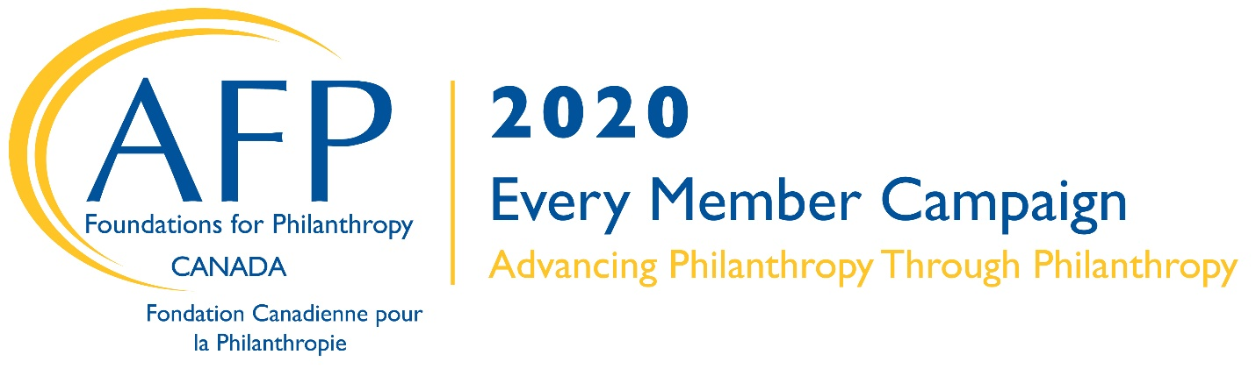FAQs
Answering frequently asked questions of AFP members related to the Every Member Campaign

Q: What is the relationship between the Association of Fundraising Professionals (AFP) and the AFP Foundation for Philanthropy- Canada?

A: The Association of Fundraising Professionals (AFP), a nonprofit membership organization, and the AFP Foundation for Philanthropy, a charitable organization, represent a typical professional association/foundation partnership. The primary focus of AFP is to advance ethical and effective fundraising worldwide. The AFP Foundation works on behalf of those who lead, serve and support nonprofit institutions in the interest of the public good. Together, AFP and the AFP Foundation, support the pillars of the fundraising profession: ethical practice, education, research, leadership development and a community of inclusion and diversity.

The AFP Foundation supports and funds programs that advance those in the profession through research grants, scholarship programs to attend fundraising events/conferences/courses, and diversity and inclusion programs, such as the Fellowship in Inclusion and Philanthropy program.

Q: Isn’t my AFP membership my support?

A: AFP membership does not “support” the Foundation. Your support of the AFP Foundation for Philanthropy is above and beyond AFP dues. When you join AFP, you receive products, programs and services in exchange for your membership. The AFP Foundation raises revenue for fundraising innovation to underwrite the creation of new or enhance existing programs and services—adding value to your membership. The AFP Foundation also works to raise awareness about the role and impact of fundraising in philanthropy to nonprofit leaders and donors and the general public.

Q: What are the different ways to support AFP and the AFP Foundation?

A: Membership Dues to the Association of Fundraising Professionals (AFP)
- Members receive direct benefits in exchange for their membership purchase

Donations to the AFP Foundation for Philanthropy
- The AFP Foundation is a nonprofit organization. Contributions are tax deductible to the fullest extent of the law.

Q: How will I be recognized for my gift to the BE the CAUSE Campaign?

A: All donors are recognized by the AFP Foundation through online donor listings and in AFP’s annual report. Those giving $1,000 or more are also acknowledged on signage at the AFP International Conference on Fundraising, as well as AFP Toronto Congress. On a local level, donors should receive a donor pin and additional recognition from their chapter.

Donor Recognition Levels:
• President’s Club: $1,000-$2,499
• Ambassador’s Club - Emerald Level: $500-$999
• Ambassador’s Club - Ruby Level: $250-$499
• Ambassador’s Club -Sapphire Level: $100-$249
• Friends of the Foundation: $50 to $99

For information about giving levels of $2,500 or more and special giving circles such as Leadership Society, Omega Circle, contact the AFP Foundation for Philanthropy- Canada at
1-800-796-7373.

Q: How do I make my contribution to the AFP Foundation?

A: 1. One-Time Gift: Donate
a. Online: https://afpglobal.org/how-give-afp-foundation-philanthropy-canada
b. Mail a cheque: AFP Foundation for Philanthropy- Canada, 260 King Street East, Suite 412, Toronto, ON M5A 4L5.
Or call with a credit card: 416-941-9144 OR Toll Free: 1-800-796-7373
2. Monthly Giving: Make a recurring gift and become a member of the Alpha Society
a. Submit the online Alpha Society form at https://afpglobal.org/how-give-afp-foundations-philanthropy
b. Call to set up your monthly giving: 800-666-3863 x448.
3. Pledge: Make a pledge with a specified payment schedule
a. Submit the online pledge form at https://afpglobal.org/how-give-afp-foundation-philanthropy-canada
b. Ask your chapter for a pledge form
4. Planned Giving: Omega Circle
a. ask your chapter for more information about the Omega Circle
b. call the AFP Foundation for Philanthropy Canada: 1-800-796-7373

