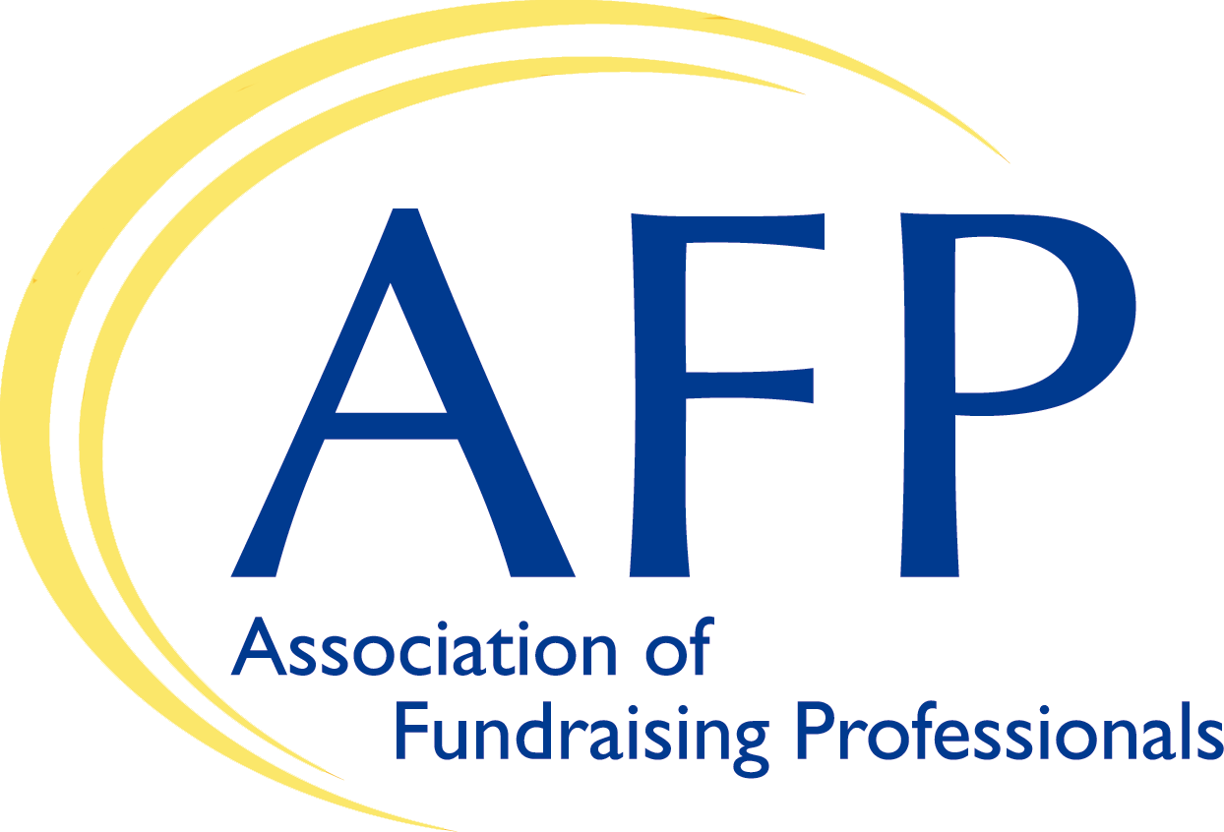 [USE CHAPTER LOGO!)
AFP NEWS

DATE: DATE
FOR RELEASE: Immediate
CONTACT: [Chapter Contact: Name, Phone, Email Address]

[AFP Chapter Name] Meets with [Member of Congress] to Help Increase Charitable Giving

In an effort to increase charitable contributions during the pandemic when many charities and nonprofits are suffering and finding it more difficult to provide services to the community, members of the [AFP Chapter Name] recently met with and asked [Member of Congress] for [his/her] support of key giving legislation.
The [AFP Chapter Name] represents [number of members] in the [city, area or region] and is part of a larger network of 26,000 fundraisers and charities around the world that collectively raise over $100 billion annually for a wide array of causes and missions. All members are required annually to sign AFP’s Code of Ethics, the only enforceable code in the fundraising profession.
“It was great to meet with [Member of Congress] and talk about the important work of charities in the [city, area or region],” said [Chapter Rep Name]. “[He/she and/or their staff] were very interested in our issues and understood how fundraisers and charities improve our local community.”
[Number] members of the [AFP Chapter Name] met with [Member of Congress and/or their staff] and asked [him/her] to support measures to increase giving, including:
- The universal charitable deduction, which would allow any taxpayer, even if they didn’t itemize their taxes, to take a deduction for their charitable gifts.
- The IRA rollover, which would allow donors to “roll over” funds from their IRA tax-free to a charity.
“If enacted, these bills would dramatically increase giving—by the billions—every year, and that’s so important as so many charities have been struggling over the last year to continue to provide critically-needed programs and services to the community,” said [Chapter Rep Name]. “Here in [city, area or region], we’ve seen….[Sentence or two on the general impact of the pandemic on the local community and how additional giving would improve things].
In addition, the [AFP chapter name] asked [Member of Congress] to talk with the United States Postal Service about rapidly rising postage rates (6.0 – 8.5%) far higher than the rate of inflation, placing additional and unfair costs on charities.
“We support a strong Postal Service, as charities rely on mail to communicate with donors and the public,” said [Chapter Rep Name]. “However, charities are already suffering from continued postal delays, with some mail from 2020 still not being received. We are ready to pay our fair share, but trying to fund the Postal Service on the backs of charities is unfair and ultimately hurts the whole community.”
The meeting was part of AFP’s Virtual Lobby Week, involving chapters from across the U.S. meeting with members of Congress to educate them about charitable giving proposals and ask them for their support.
The [AFP Chapter Name]…[sentence or two on what the chapter does in the local community.]

