AFP GLOBAL – CHAPTER ADMIN PORTAL USAGE GUIDE

Login via website to afpglobal.org

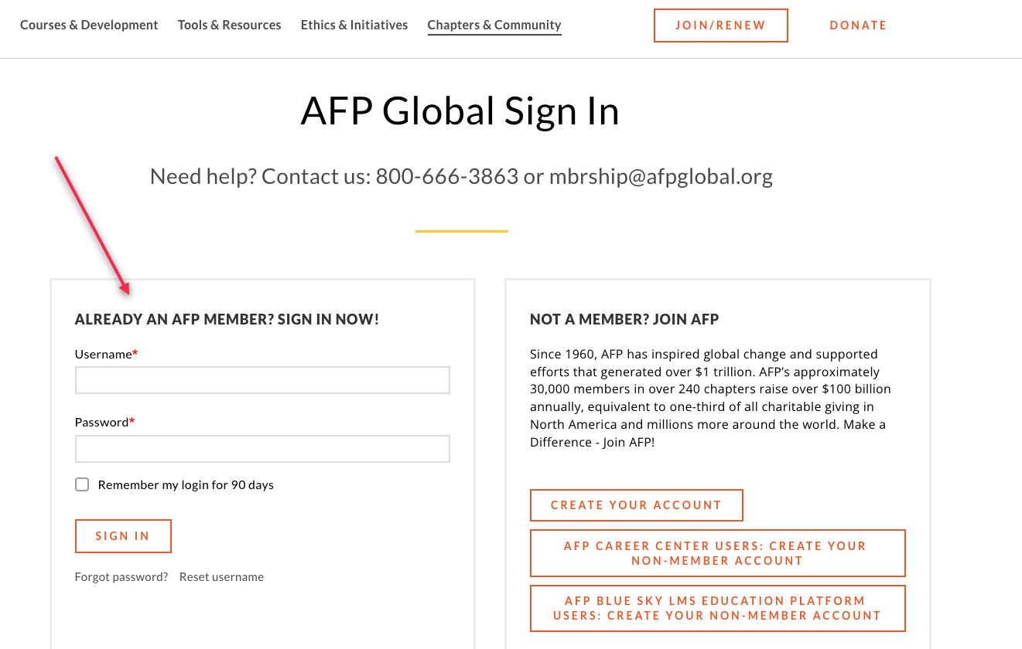

Chapter Portal Landing Page

Click on the name of the chapter to navigate to the chapter details.
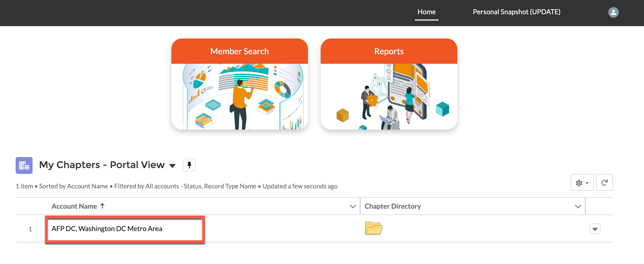

On the next page you have the option to make updates to the chapter details by clicking edit. Don’t forget to click on the Save button when you are done.

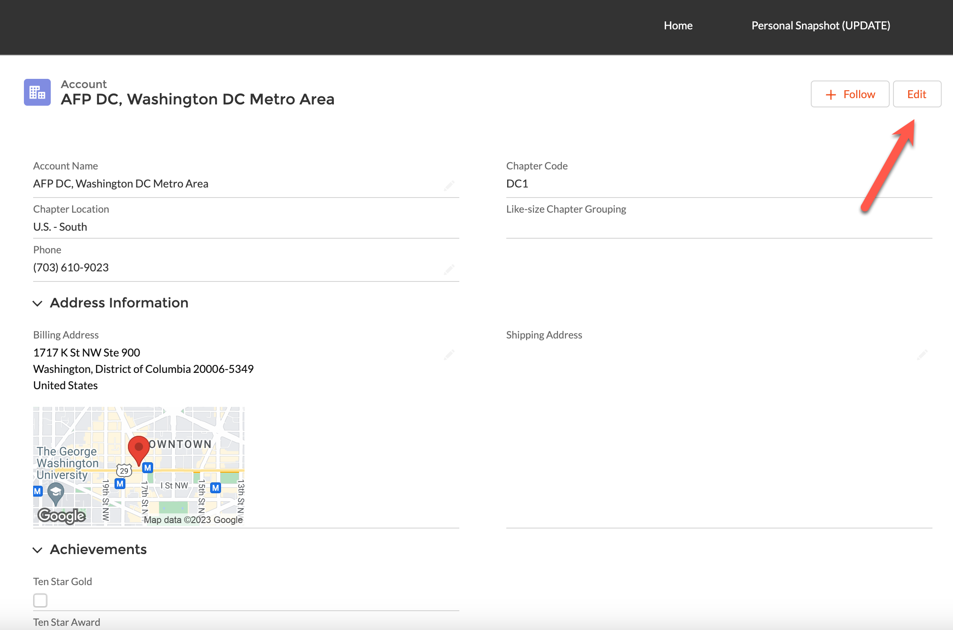

MEMBER DIRECTORY

There are 2 ways to see your list of members. Member Search and Chapter Directory. We will start by clicking on the folder icon.

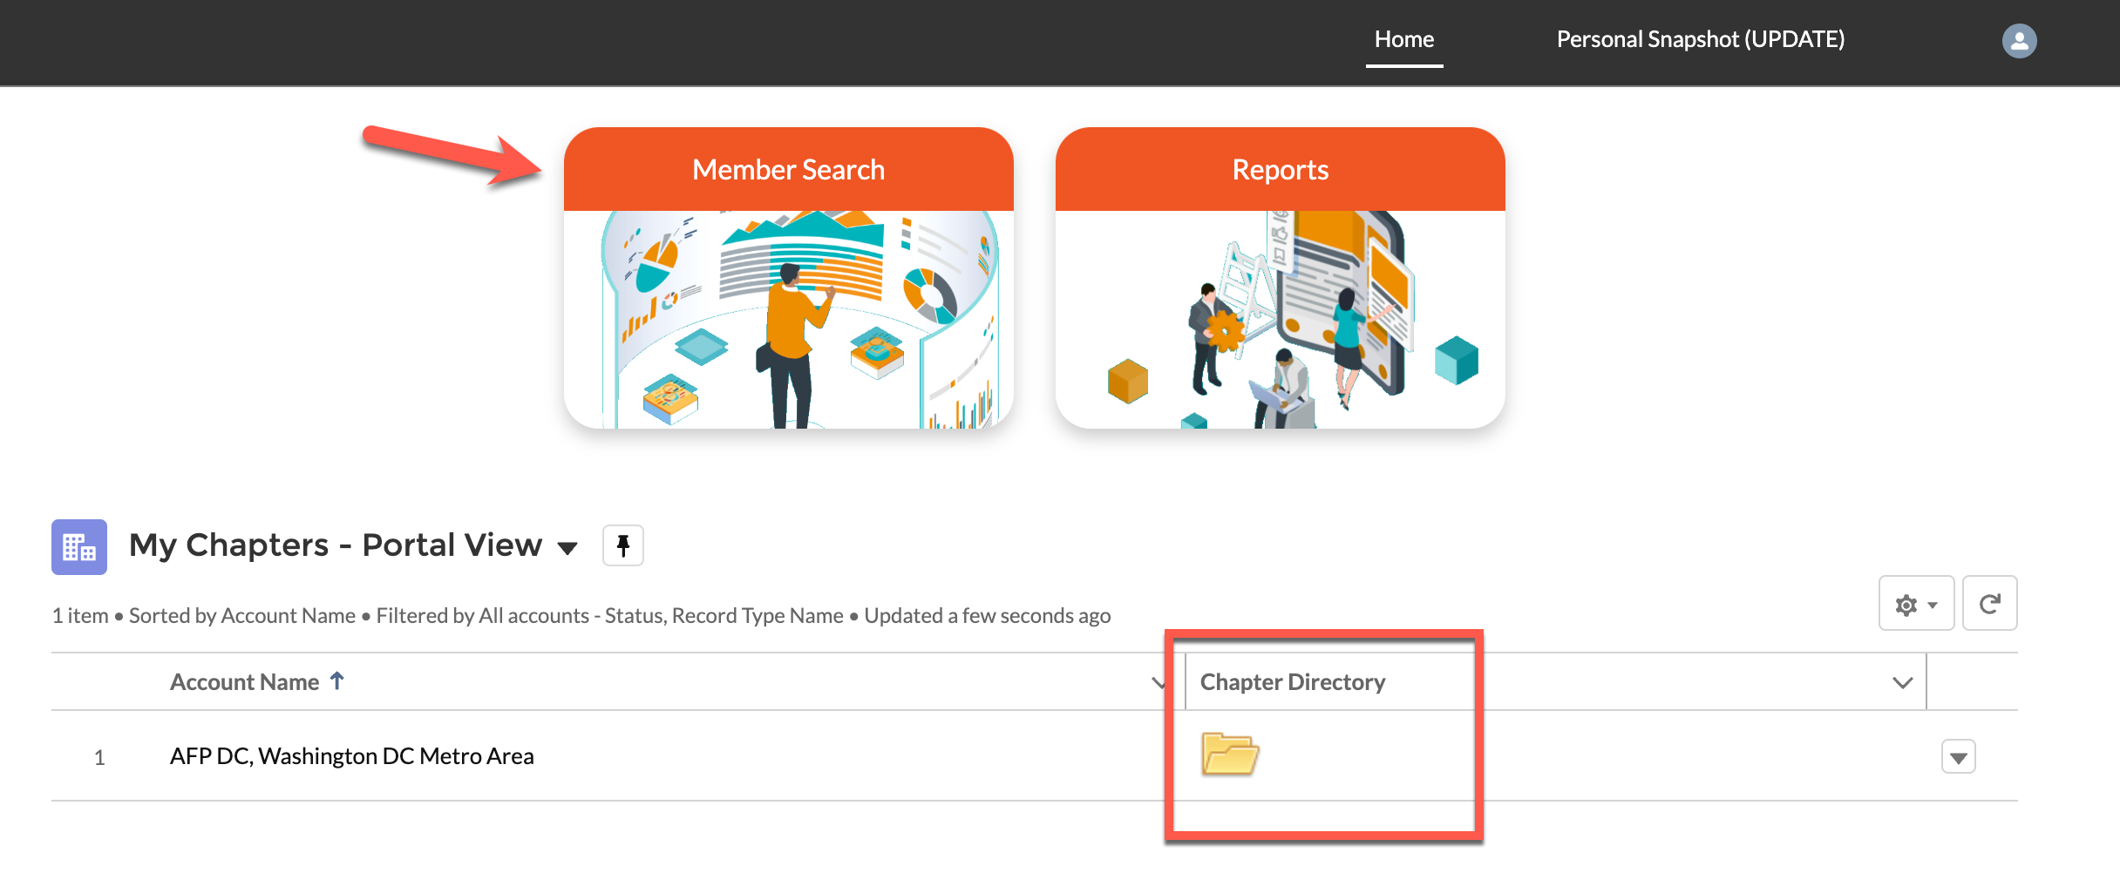

You have several search options to choose from. You will see the list of members at the bottom.

You may have to scroll left to right to see more data OR down to see more members. You can also do a quick search from this section using just the name of the person you are looking for. If you click on the name of a person’s first or last name, you will be taken to that person’s details.

If you chose the Member Search Icon, this is the page you would see.
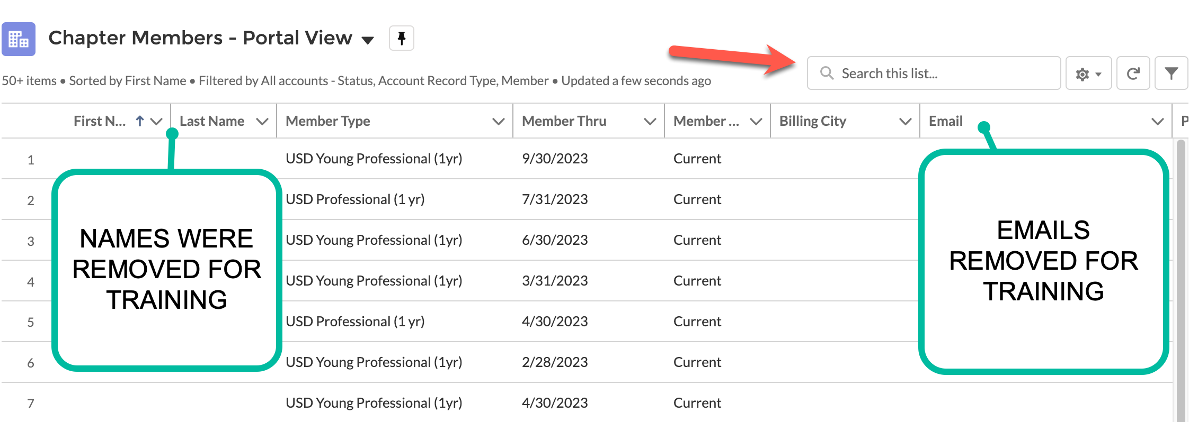
You can edit details here if necessary.

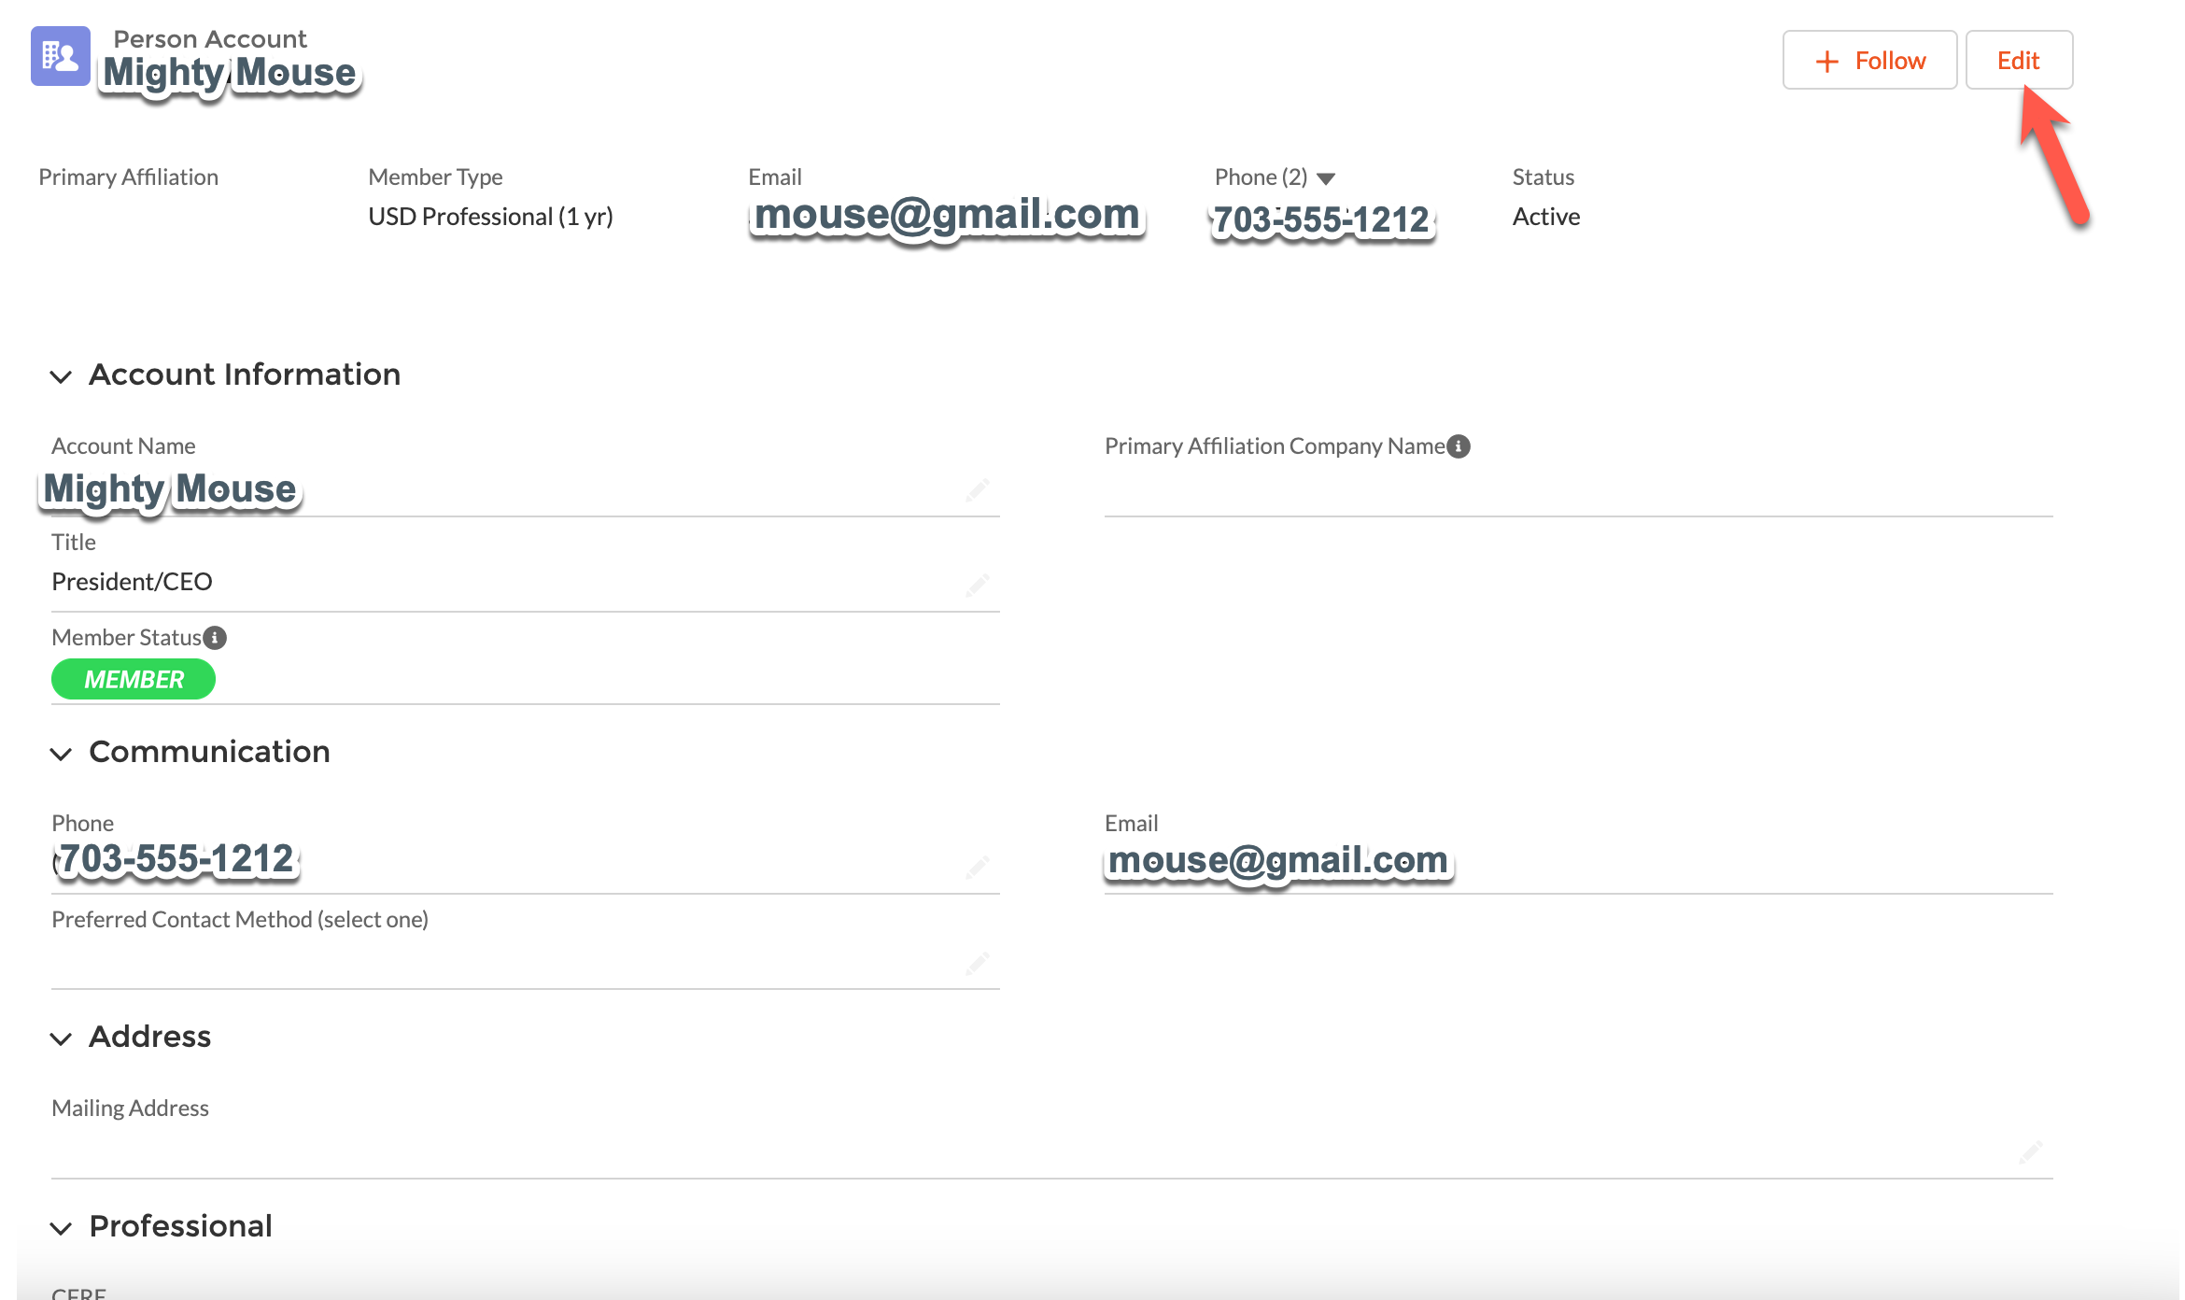

Chapter Reports
To access Reports Click on the Reports icon. There are samples of these reports at the end of this user guide.

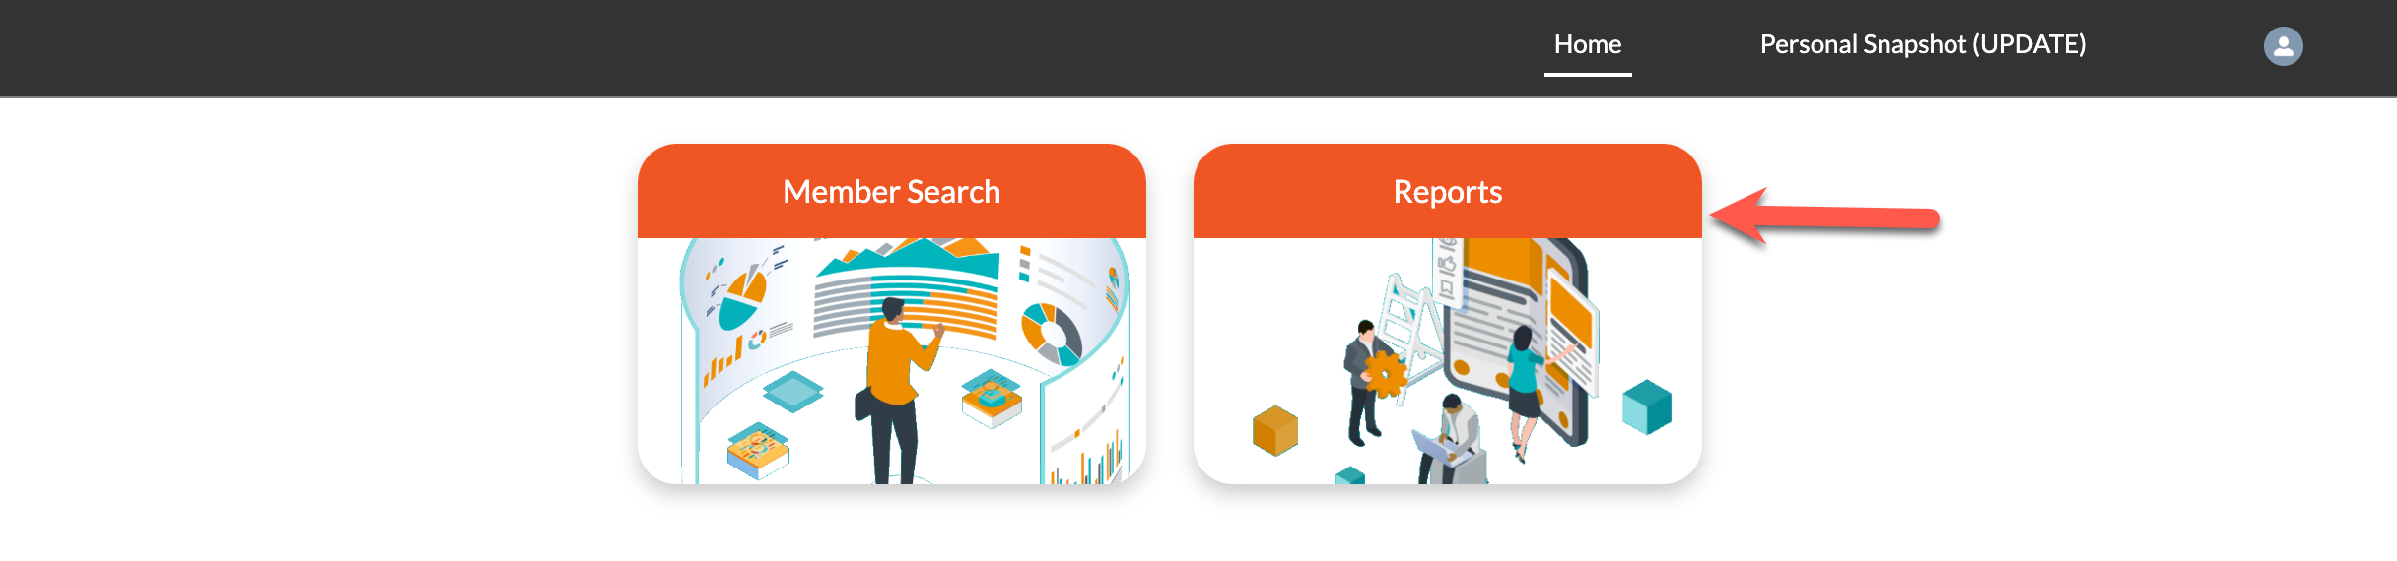

Click on All Reports. The reports you have access to will be displayed. To run the report, click on the report name.

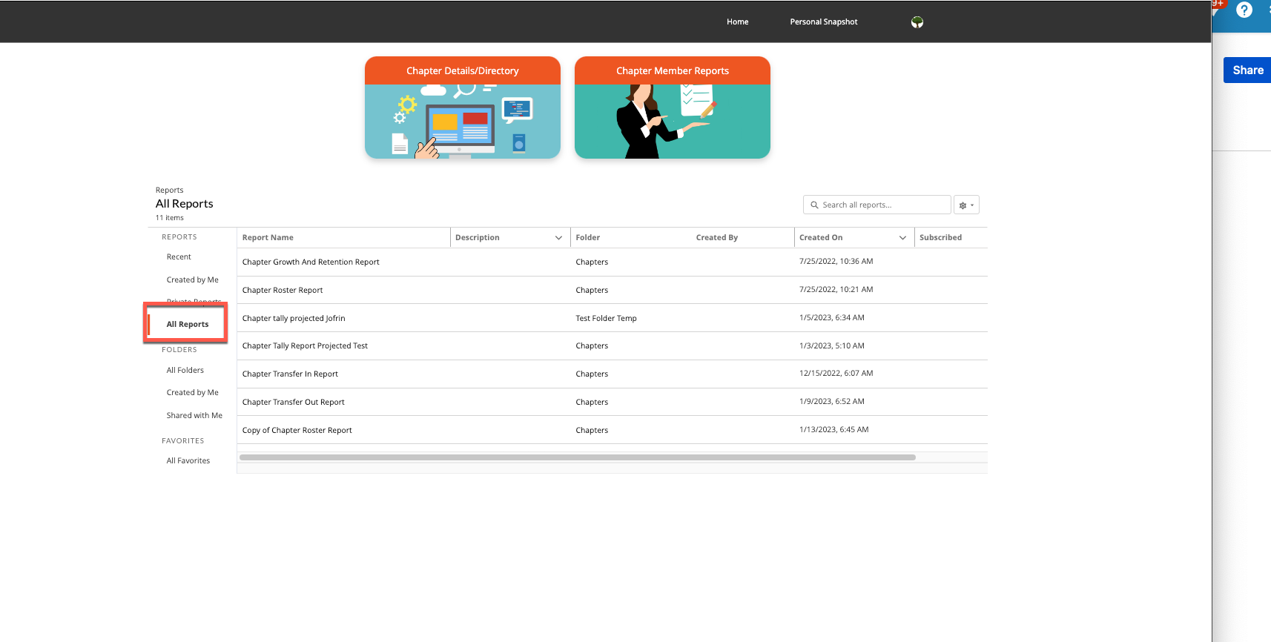

Once you run the report, you will have the ability to update some filters as well as export the report. To see more data you can scroll to the left as well as down on the right.

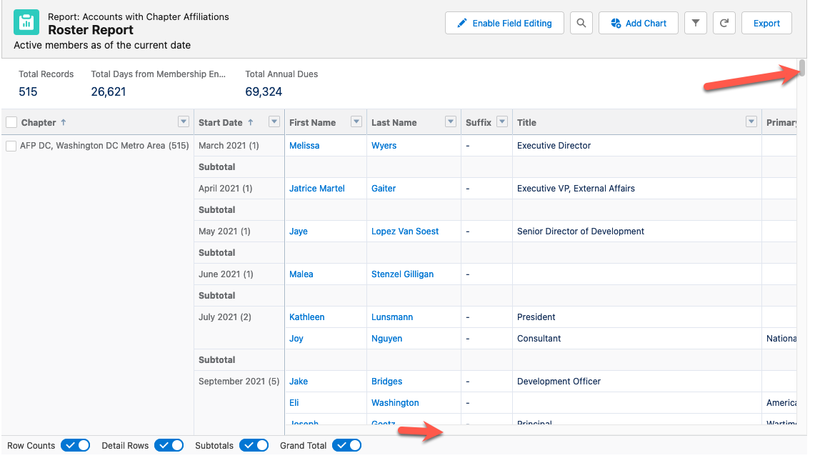

You can click funnel icon to change the date range.

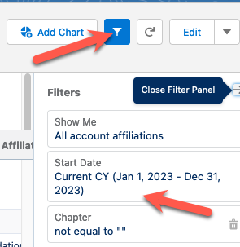

You can choose to export the report formatted the way you see it on in the run view or you can export details only which may cause your report to look a little different. The report will save to your download folder.

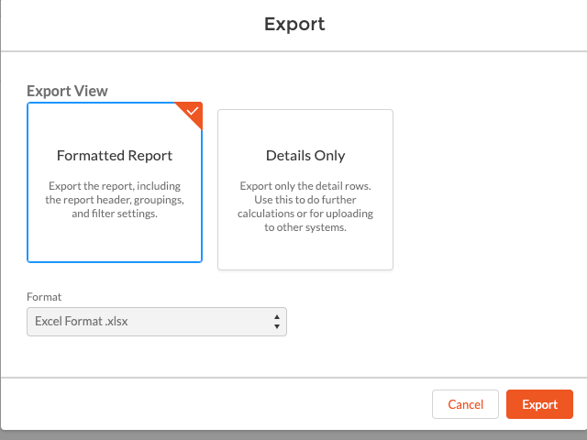

Sample Reports:

