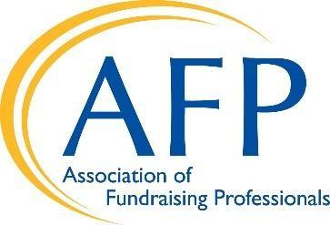 **Charitable Act (H.R. 3435/S. 566)**

**Support Universal Charitable Deduction**

The universal charitable deduction, which allowed all taxpayers (even non-itemizers) to take a charitable deduction of up to $300 for an individual and $600 for a couple, expired at the end of 2021.

The Charitable Act (S. 566/H.R. 3435) is a bipartisan, bicameral bill. It seeks to expand and extend the expired non-itemized deduction for charitable giving that would ensure Americans who donate to charities, religious organizations, and other nonprofits of their choice are able to deduct that donation from their federal taxes at a higher level than the previous $300 deduction. The sponsors are Senators Lankford (R-OK) and Coons (D-DE) in the Senate, and Representatives Blake Moore (R-UT), Danny Davis (D-IL), Michelle Steel (R-CA), and Chris Pappas (D-NH) in the House.

Generous Americans give over $500 billion annually to charities in their communities. Charitable dollars are essential to maintaining a healthy civil society, vital to both nonprofit charities and local governments that depend on these resources to achieve their critical missions.

# Historic Drop in Charitable Giving Without Universal Deduction

* In 2020, taxpayers used the temporary universal charitable deduction to give $10.9 billion to charities; a quarter of Americans taking that $300 deduction made less than $30,000. While there are many factors that contribute to increased giving, one key factor is clearly the availability of the charitable deduction to nonitemizers.
* According to data compiled by AFP’s [**Fundraising Effectiveness Project**](https://afpglobal.org/FundraisingEffectivenessProject), the number of small donations went up in 2020 and 2021 after Congress enacted a universal charitable deduction but then small-gift donors collapsed in 2022 after the temporary universal charitable deduction was not renewed. The data reports decline in key fundraising metrics including dollars donated, number of donors, and donor retention rate.
  + Specifically, the Q4 2023 report noted from 2022 to 2023: donors contributing less than $500 were responsible for 79.3% of the overall decrease in donors; and
  + The new Q1 2024 report shows this continued trend of over reliance on major donors as micro-sized donors (those that gave less than $100) sustained the largest drop among donors, decreasing by 10.4%.

The charitable deduction is a good tax policy – it encourages individuals to give away more of their income, devoting it to their community’s needs rather than their own. And it will provide needed resources for charitable and faith-based organizations to continue providing vital services to families, workers, and communities.

# Congress Should Restore Non-Itemizer Charitable Deduction

AFP Global is a leading supporter of the Charitable Act and has been joined by more than 1,000 charities from all 50 states.

**Please cosponsor the Charitable Act (S. 566/H.R. 3435)!**