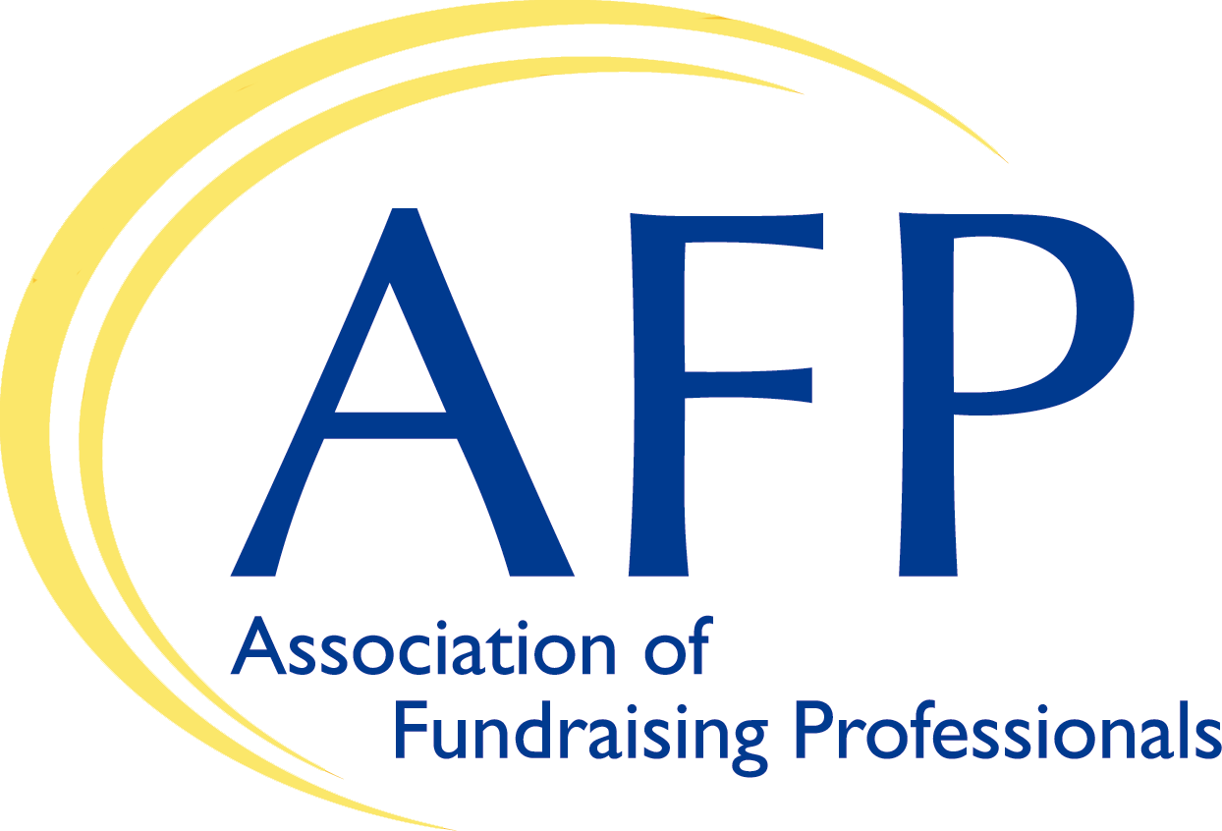 [USE CHAPTER LOGO!)
AFP NEWS

DATE: DATE
FOR RELEASE: Immediate
CONTACT: [Chapter Contact: Name, Phone, Email Address]

[AFP Chapter Name] Meets with [Member of Congress] to Ask for Support on Encouraging Charitable Giving

Many charities and nonprofits are reporting a decrease overall in charitable giving and donors now that the universal charitable deduction has expired. Charitable giving by individuals support critically-needed services to the [Local Area Name] community, and members of the [AFP Chapter Name] recently met with and asked [Member of Congress] for [his/her] support of key giving legislation.
The [AFP Chapter Name] represents [number of members] in the [city, area or region] and is part of a larger network of 26,000+ fundraisers and charities around the world that collectively raise over $115 billion annually for a wide array of causes and missions. All members are required annually to sign AFP’s Code of Ethics, the only enforceable code in the fundraising profession.
“It was great to meet with [Member of Congress] and talk about the important work of charities in the [city, area or region],” said [Chapter Rep Name]. “[He/she and/or their staff] were very interested in our issues and understood how fundraisers and charities improve our local community.”
[Number] members of the [AFP Chapter Name] met with [Member of Congress and/or their staff] and asked [him/her] to support measures to increase giving, including:
- The bipartisan Charitable Act (S. 566/H.R. 3435), which would allow the 91% of taxpayers that don’t itemize their taxes to still be entitled to take a deduction for their charitable gifts.

AFP’s Fundraising Effectiveness Project (FEP) has found that people responded positively to the giving incentives in the universal charitable deduction, which expired at the end of 2021. Gifts of exactly $300 (the limit of the deduction for individual taxpayers) increased by 7.5% in 2020 and 2021 compared to 2019, the latest year without the universal charitable deduction.
-more-
[AFP Chapter Name] Charitable Act - 2
Unfortunately, small-gift donors collapsed in 2022 after the temporary universal charitable deduction was not renewed. AFP’s FEP data reports a decline in key fundraising metrics including dollars donated, number of donors, and donor retention rate in 2022, and that trend has continued. From 2022 to 2023, there was a 2.8% drop in dollars, 3.4% drop in donors, and 2.5% decrease in donor retention. The report noted that donors contributing less than $500 were responsible for 79.3% of the overall decrease in donors.

“It’s clear that the universal charitable deduction works and needs to be reinstated so that charities in the [Local Area] can benefit from increased giving,” said [Chapter Rep Name]. “Here in [city, area or region], we’ve seen….[Sentence or two on the general impact of the local community and how additional giving would improve things].
The meeting was part of AFP’s Lobby Week, involving chapters from across the U.S. meeting with Members of Congress to educate them about charitable giving proposals and ask them for their support.
The [AFP Chapter Name]…[sentence or two on what the chapter does in the local community.]

-end-

