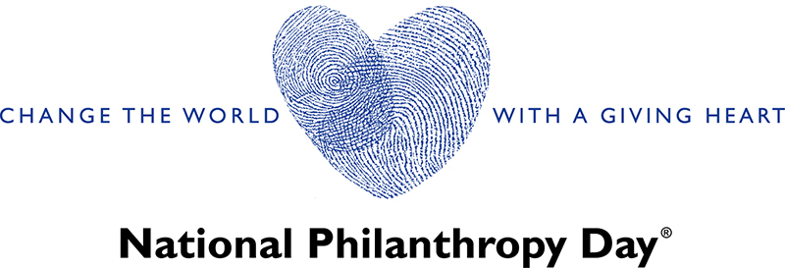
Volunteer Job Description:
Member, Marketing and Communications Subcommittee of AFP National Philanthropy Day
Position Overview:
As a member of the Marketing and Communications Subcommittee for National Philanthropy Day, you will play a crucial role in promoting the event, ensuring effective communication with stakeholders, and contributing to the overall success of the celebration. This volunteer position is an excellent opportunity for individuals passionate about philanthropy, marketing, and communications to make a meaningful impact on the community.
Responsibilities:
- Collaborative Leadership:
- Work collaboratively with the Chair of the Marketing and Communications Subcommittee to implement strategies aligned with the goals and objectives of National Philanthropy Day.
- Participate actively in subcommittee meetings, offering creative input and assisting in the planning and execution of marketing initiatives.
Committee Roles/Tasks:
- Content Development:
- Contribute to the development of compelling and impactful content for various marketing channels, including digital and print.
- Draft engaging copy for promotional materials, newsletters, website content, and social media posts.
- Social Media Management:
- Assist in developing and executing a comprehensive social media strategy to build excitement and engagement around National Philanthropy Day.
- Create and curate content for social media platforms, including posts, images, videos, and stories.
- Digital Marketing:
- Collaborate with the subcommittee to implement digital marketing campaigns, including email marketing and online advertising.
- Assist in managing the event website, ensuring it provides relevant information, registration details, and engaging content.
- Visual Identity and Branding:

- Contribute to the development and maintenance of a cohesive visual identity for National Philanthropy Day, adhering to organizational branding guidelines.
- Assist in creating marketing collateral, such as flyers, posters, brochures, and digital assets.
- Media Relations:
- Support efforts to establish and maintain relationships with local media outlets, journalists, and influencers.
- Assist in coordinating media interviews and facilitating media coverage during National Philanthropy Day.
- Event Promotion:
- Work closely with the subcommittee to promote National Philanthropy Day through various channels, maximizing visibility and attendance.
- Assist in developing promotional materials and strategies to highlight the impact of philanthropy in the community.
- Video Productions and Editing
- Event Day support
- Eblasts
Qualifications:
- Demonstrated interest in marketing, communications, or related fields.
- Excellent written and verbal communication skills.
- Familiarity with social media platforms and digital marketing tools.
- Creative thinking and a proactive approach to problem-solving.
- Ability to work collaboratively in a team and contribute innovative ideas.
- Enthusiasm for philanthropy and a desire to contribute to a meaningful cause.

