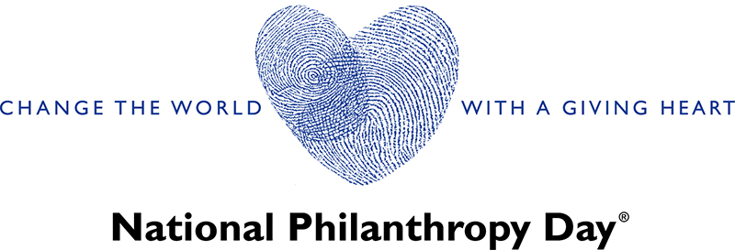
Volunteer Job Description:
Member, Nominations and Awards Sub Committee
Position Overview:
As a member of the Nominations and Awards Committee for [Your Organization's] National Philanthropy Day, you will play a vital role in recognizing and celebrating outstanding contributions to philanthropy. This volunteer position provides an opportunity for individuals passionate about philanthropy to contribute to the acknowledgment of remarkable individuals, corporations, groups, or teams within our community.
Responsibilities & Tasks:
- Nomination Process:
- Contribute to the development and refinement of the nomination process, ensuring clarity, inclusivity, and alignment with the values of National Philanthropy Day.
- Promote the nomination process to encourage diverse and meaningful submissions from the community.
- Review and Assessment:
- Participate actively in the review and assessment of nominations, applying established criteria and considering the impact of nominees' philanthropic efforts.
- Ensure fairness, transparency, and impartiality throughout the evaluation process.
- Selection Process:
- Collaborate with committee members to facilitate the selection process for award recipients.
- Engage in thoughtful discussions to reach consensus on honorees, considering their philanthropic achievements and alignment with the spirit of National Philanthropy Day.
- Communication with Nominees:
- Assist in communicating with nominated individuals, corporations, groups, or teams, ensuring they are informed about the status of their nomination and any additional information required.
- Recognition Planning:
- Work closely with the Event Planning Committee to plan and coordinate the recognition of award recipients during the National Philanthropy Day event.
- Contribute to the development of acknowledgment strategies that highlight the significance of each honoree's contributions.
- Stakeholder Engagement:

- Engage with nominees, honorees, and their networks to foster positive relationships and highlight their philanthropic achievements.
- Act as a representative of the Nominations and Awards Committee, promoting its significance within the community.
Qualifications:
- Demonstrated passion for philanthropy and a commitment to recognizing and celebrating its impact.
- Excellent organizational and time management skills, with an attention to detail.
- Strong interpersonal and communication skills for effective collaboration within the committee.
- Ability to uphold confidentiality and professionalism throughout the nominations and awards process.
- Commitment to diversity and inclusivity in the selection and recognition of honorees.

